**Boeing Anchoring AR project – Final Report**

Chen Zhu, Steven Bergner

## 1. Background and Motivation:

**Background:**

This project originated from Boeing company, who hope to digitalize the repair inspection pipeline via using IPad and airplane 3D model. The goal of this project is about anchoring a 3D aircraft model on a given image or a series of images (videos) in real time.

**Previous work, research and experiment**

Previous research focusing on solving this problem by using deep learning method. **PoseNet** was proposed to applied in our case after comparison with several potential models. (“ProjectReportSFU_Phase1.pdf”)

## 2. Improve the performance of PoseNet:

### 2.1 Challenge and bottleneck:

Current state: shortcoming of poseNet

1. large amount of field data are required for training

2. performance of PoseNet is not inaccurate and unstable subject to the brightness, background, airplane textures of field data.

**Problem analysis:**

Performance of previous experiments with PoseNet didn’t offer stable accurate. We observed a discrepancy between ground truth and predicted pose. And the difference varies subject to training data with different background, brightness of images.

* **The influence of brightness of images:**

To verify the influence of the lighting, we changed the brightness of the initial working test images using gamma correction and tested them on the trained network and the results were completely off. (the second figure below)

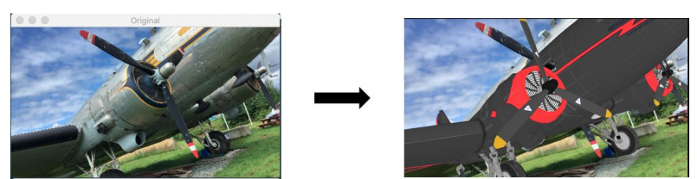

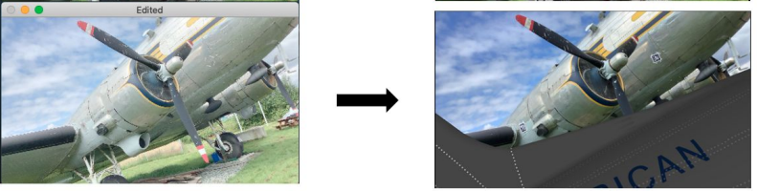

**Solution:**

We perform data augmentation by generate five additional version of each image with changed brightness.

* **Influence of background**

Test filed data took in different weather (sunny day), the results was completely off.

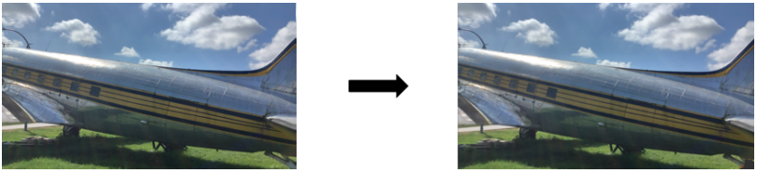

Significant improvement was seen when we manually change the background to the that of training data

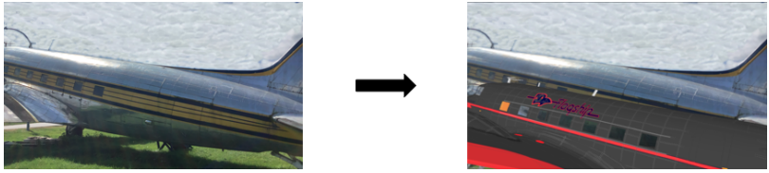

**Potential Solution:**

1. collection more data on different days with various weather conditions.

2. Implement segmentation to remove the background

**We implemented the second alternative.**

Use DeeplabV3 model to produce the segmentation of training data. Pretrained model was not able to offer decent segmentation on out dataset (synthetic data generated by Unity3D), moreover, the segmentation performance is also sensitive to brightness of images. For example, as shown blow, the segmentations from same image with different brightness are noticeably different.

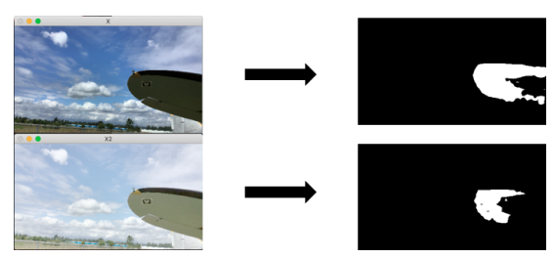

We consider to fine tune Deeplab model to improve the precision of segmentation and measure its impact on pose estimation results.

### 2.2 Training on Deeplab model

Training deeplab on custom Dataset to get more precise segmentation

- Base on the source code of Deeplab mode in tensoflow, adjust custom dataset format to be compatible with training deeplab.

- training on 32000 synthetic images with 6000 epochs

- some result on test data (test data is field data captured from real world)

Result analysis

* Overall, further train did bring decent result for most images

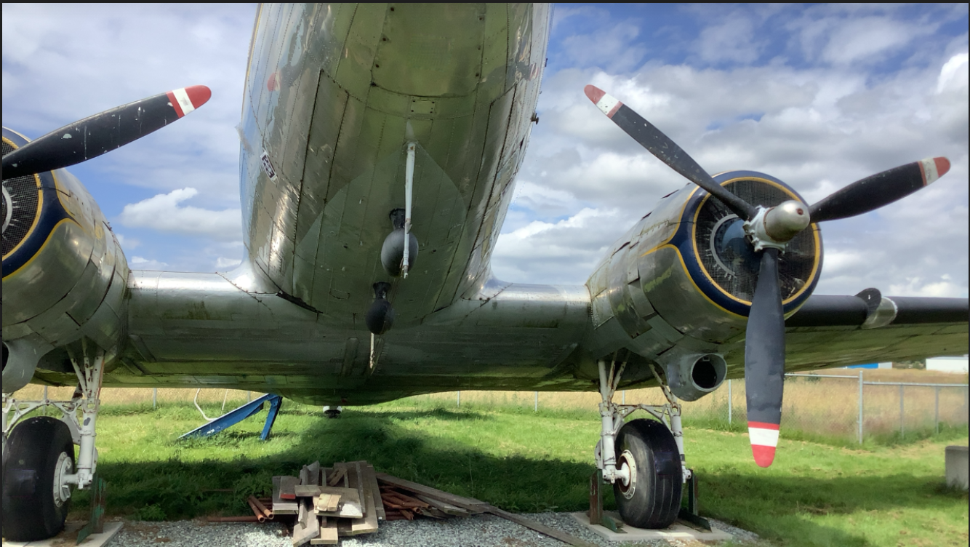 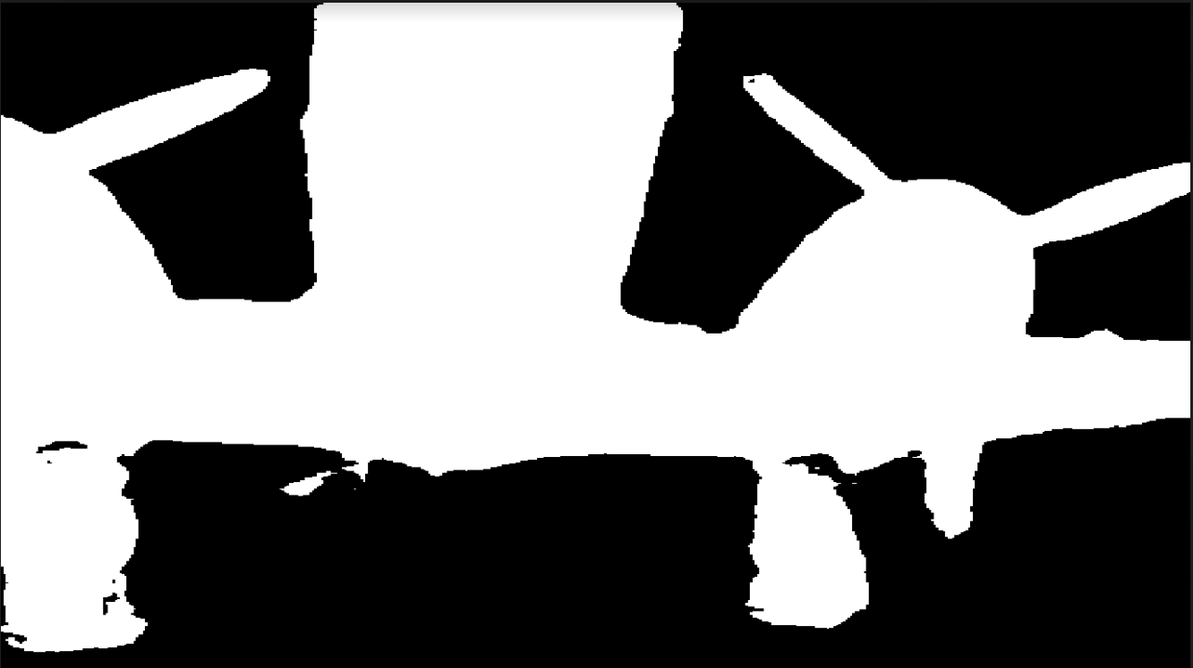

* Compared to the pretrained model, noticeable improvements saw on some ambiguous detail and edges.

Original images pretrain model fine-tuned model

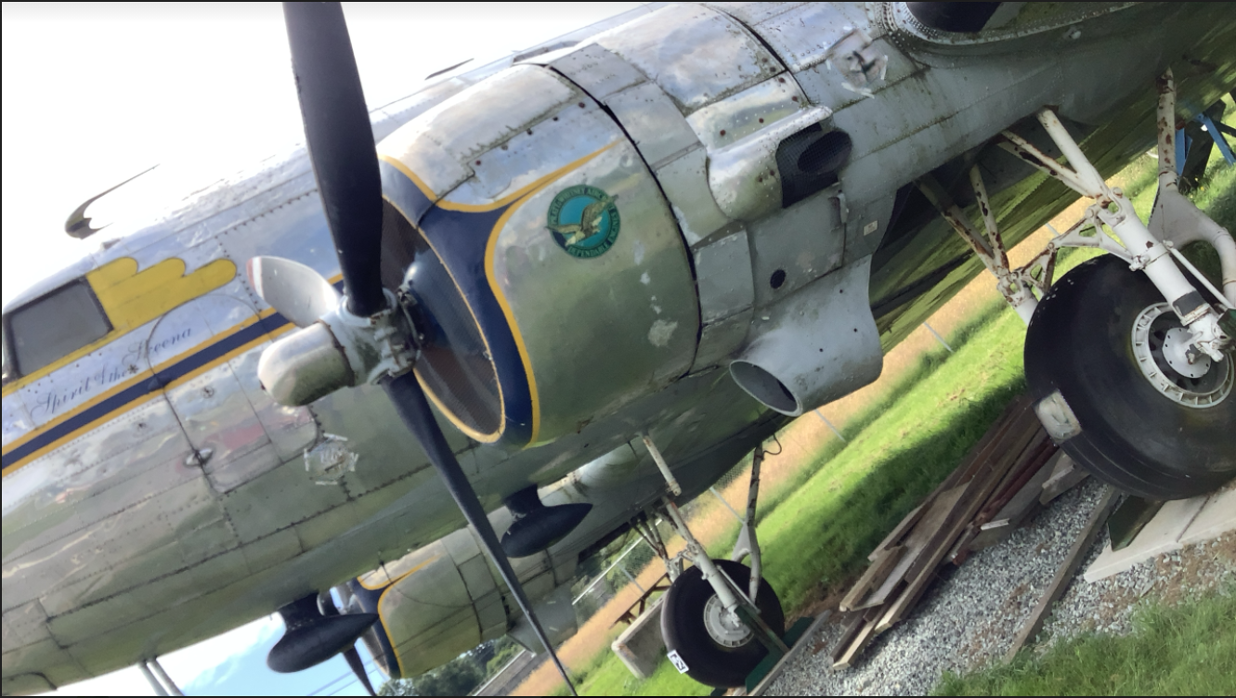 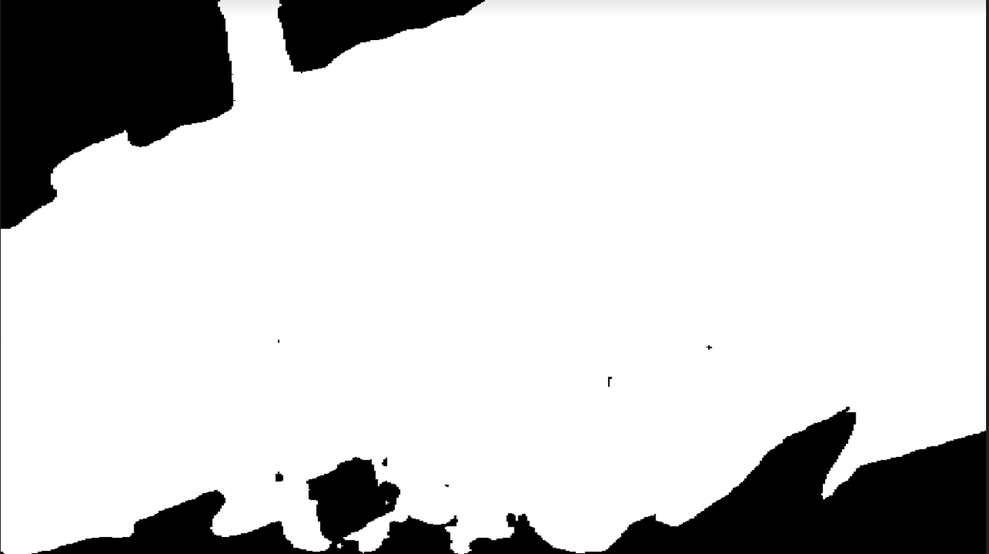 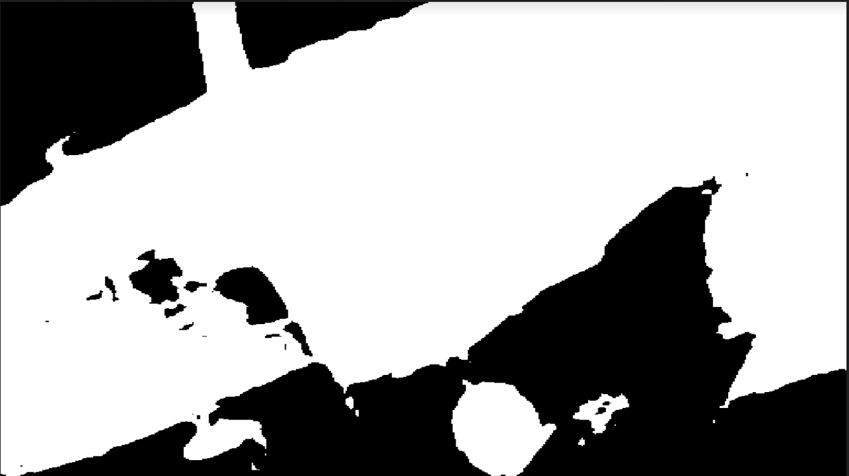

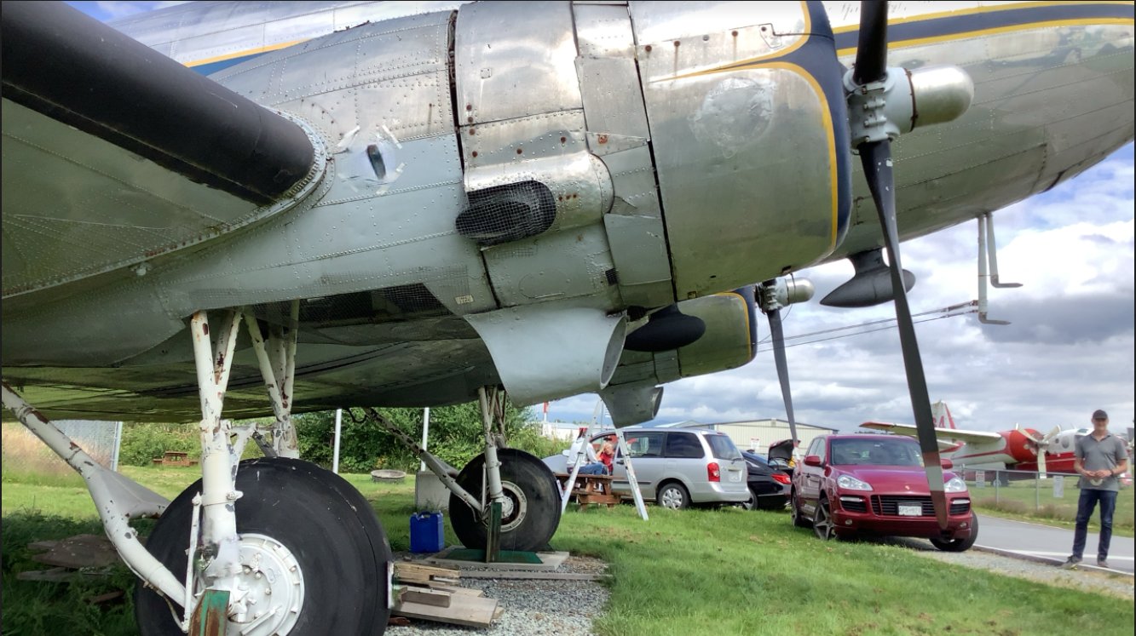 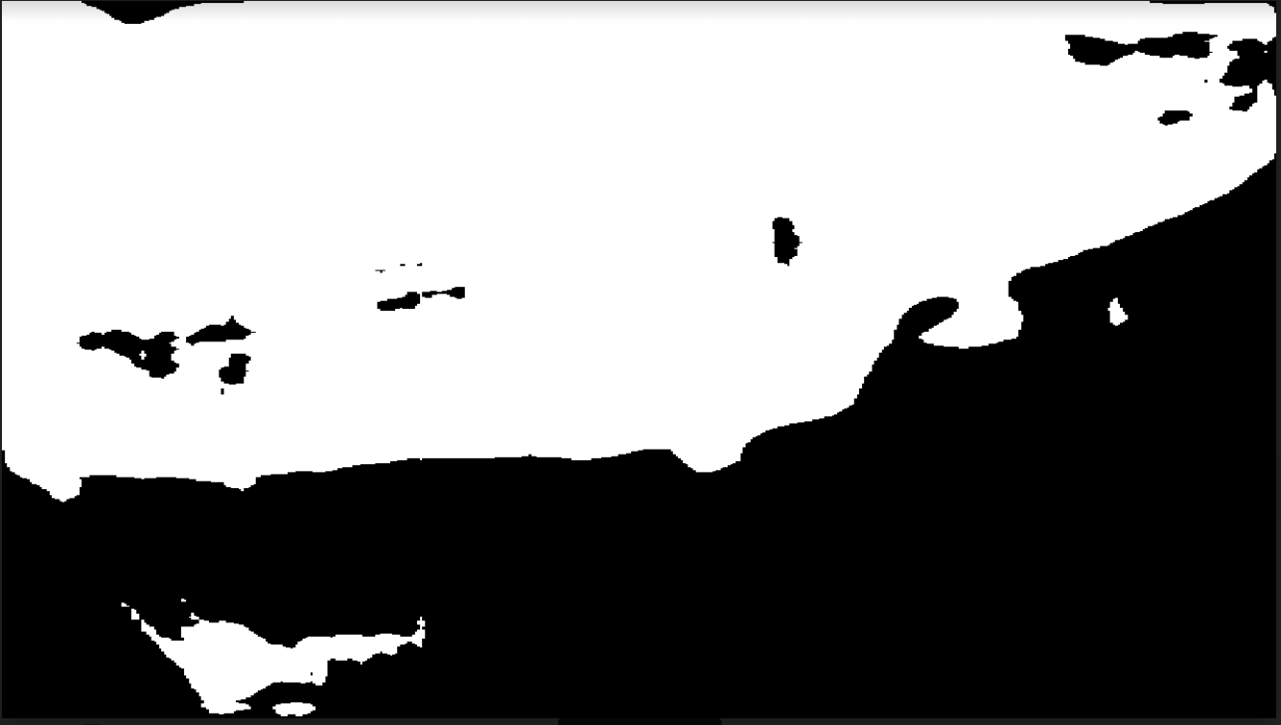 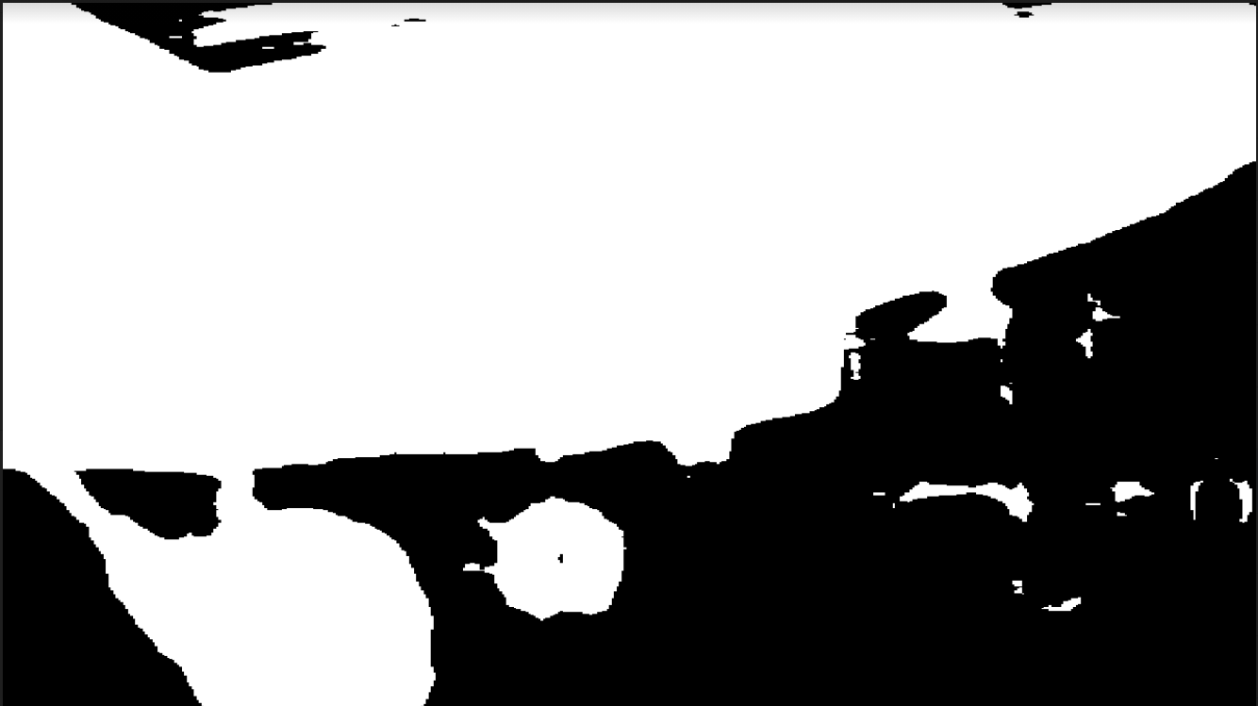

* The mostly improved performance were found in images where just particular parts of airplane are shown, which indicates that further training it is helpful for recognizing certain components.

Original images pretrained model fine-tuned model

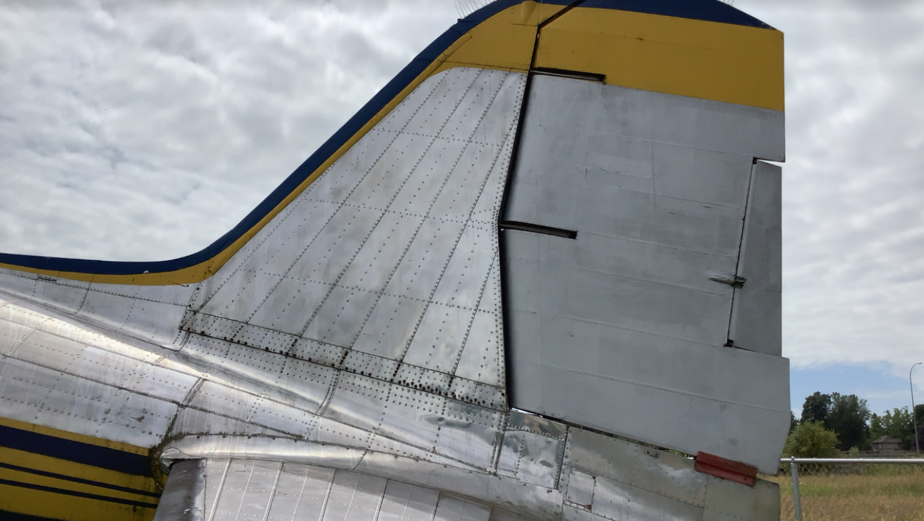 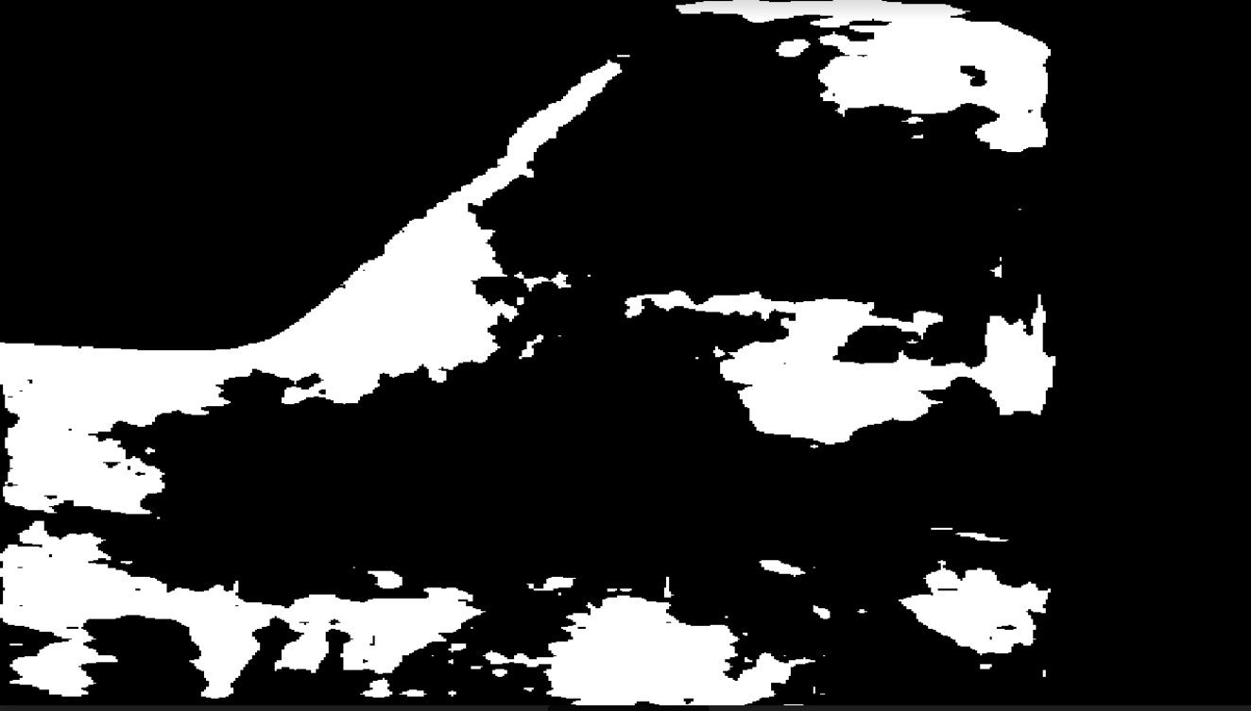 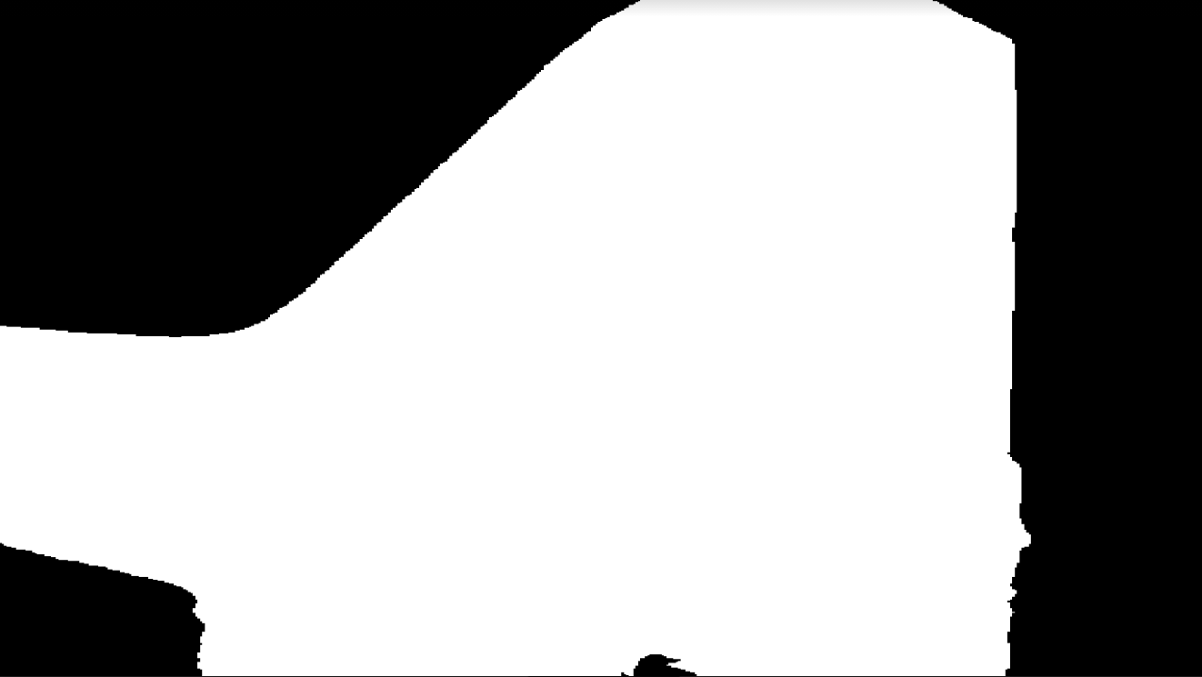

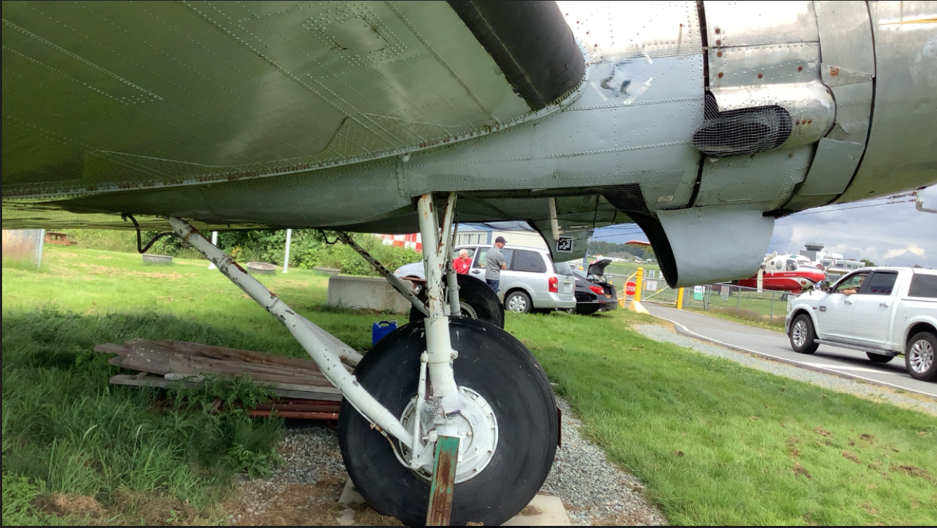 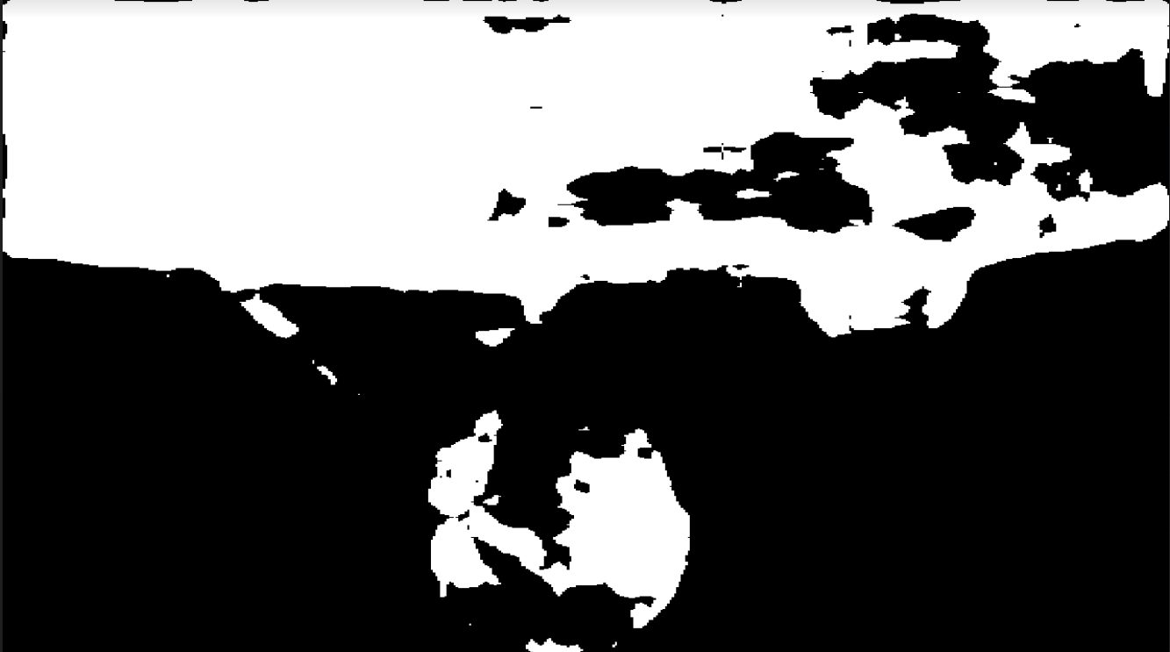 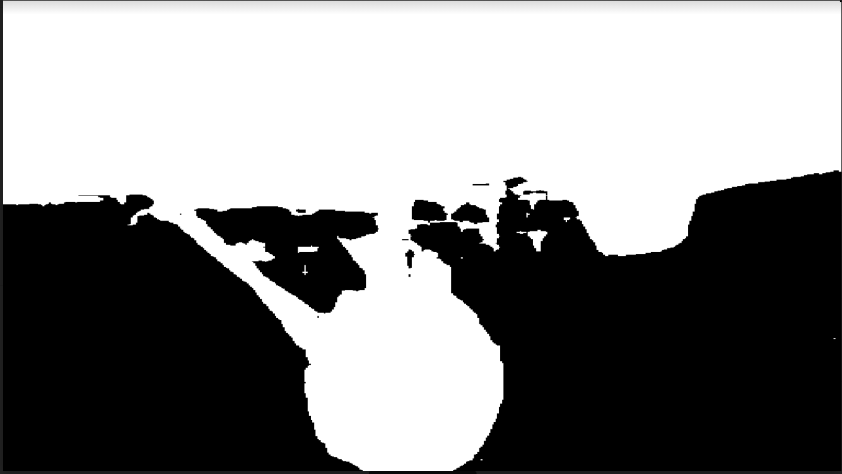

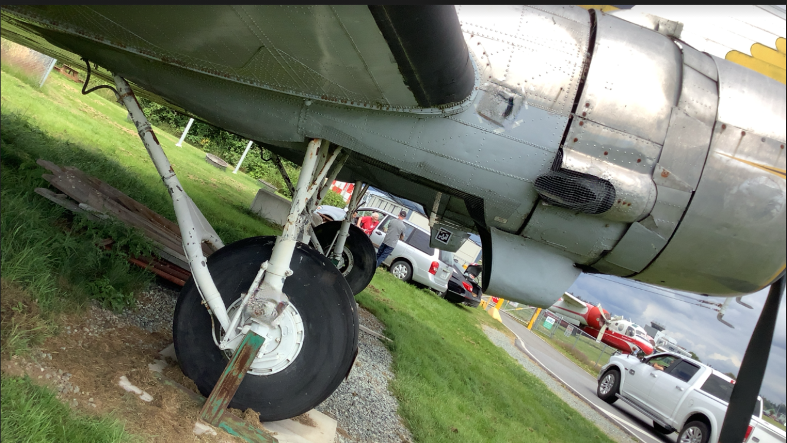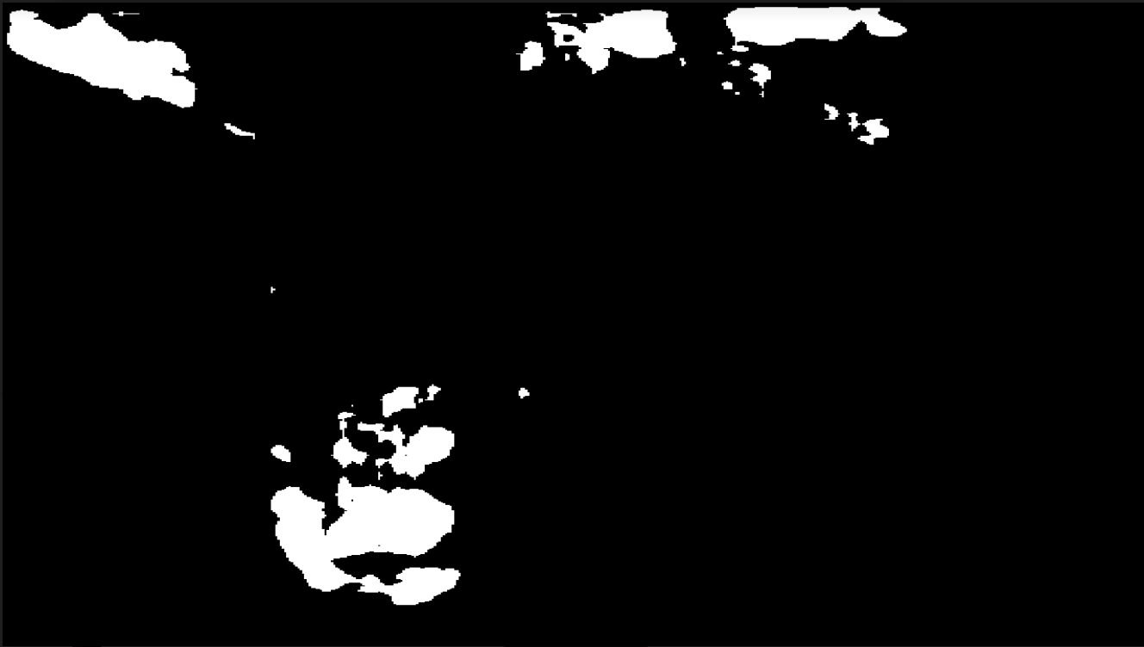 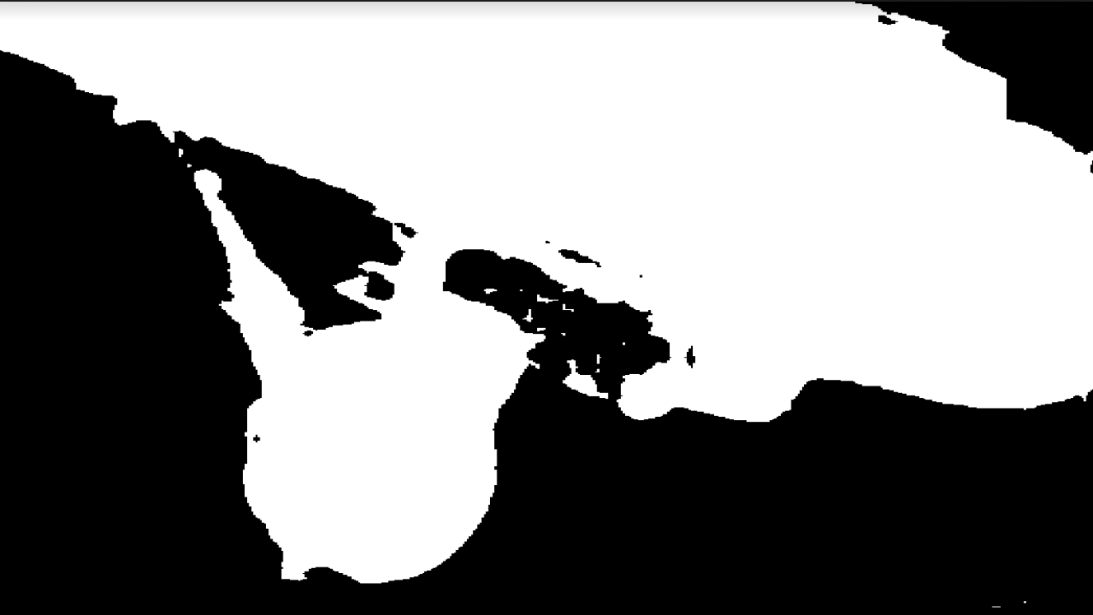

The detail Deeplab training report: “**summary_training_on_deeplab.pdf**”

**How further trained Deeplab impact the PoseNet performance:**

This part was conducted by team in Boeing.

## 3. Gap between predicted pose and ground true pose

Introduce the differentiable rendering model

Given a rough pose that’s predicted by PostNet, Can we find an approach to learn the precise pose with the minimal distance from ground truth (ideally 0)

**Redner**: a differentiable render that can take derivatives of rendering outputs with respect to arbitrary scene parameters, which means you can backpropagate from image to 3D scene parameters (e, g. the camera parameters):

<https://github.com/BachiLi/redner>

We expect Redner model help to figure out the following optimization problem: Given a target RGB image and source image with initial pose ( its pose is predicted by trained Network model such as PoseNet) generated by Redner, how to move and find **the very pose** where source image and target image overlap perfectly.

Redner allow us optimize the pose of source images to fit that of target image by minimizing the distance between target image and source image: d(t, s). In other words, ideally we will be able to iterate the pose of source, and finally find the pose of target image, where their difference should be minimum.

the design of d(t,s) is crucial to the success of optimization process. We explored several methods to compute d(t, s)

An intuitive animation of pose optimization process by using Redner, you can see teapot camera pose optimization animation “**Appendix/teapot_diff_normal.mp4**”.

Also, You can run “Teapot_pose_optimization.ipynb” to see how differentiable rendering works.

## 4. Image alignment between RGB images and rendered images

A mismatch between synthetic RGB image (Rendered by Unity) and rendered source image with same pose is found in our pipeline. Theoretically, If we have a target image and ground truth pose, the airplane in rendered source image which rendered by the ground truth pose should be perfectly overlap with that in target image. But we found much disagreement between the two in synthetic data.

RGB rendered by Unity Normal rendered by Redner difference with same pose

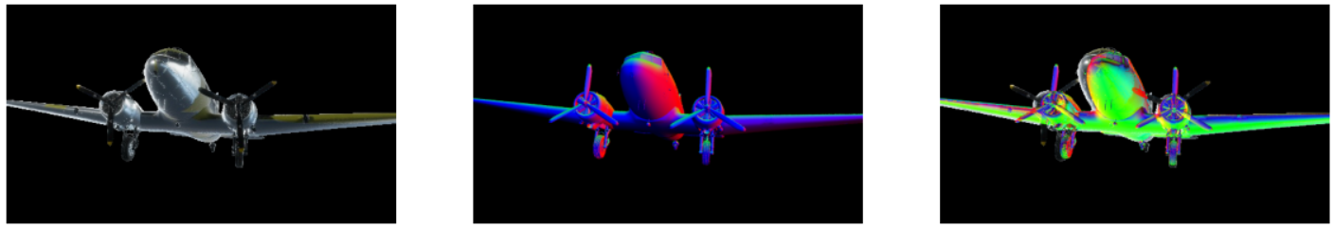

The reason is the different coordinate system mechanism between Unity and Redner. We develop another synthetic image rendering system using Blender, and found a suitable way to transform pose from blender to Redner.

This is import to our optimization process, because we expect the d(t, s) to be minimal when pose of target image and source images are exactly the same.

Rendered by Blender normal image by Redner Overlap the two images

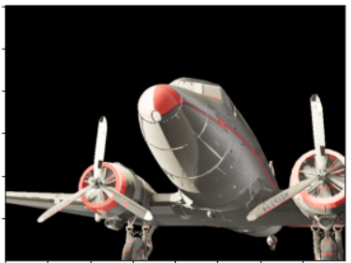 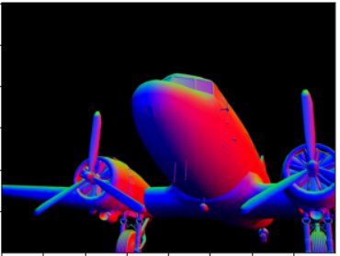, 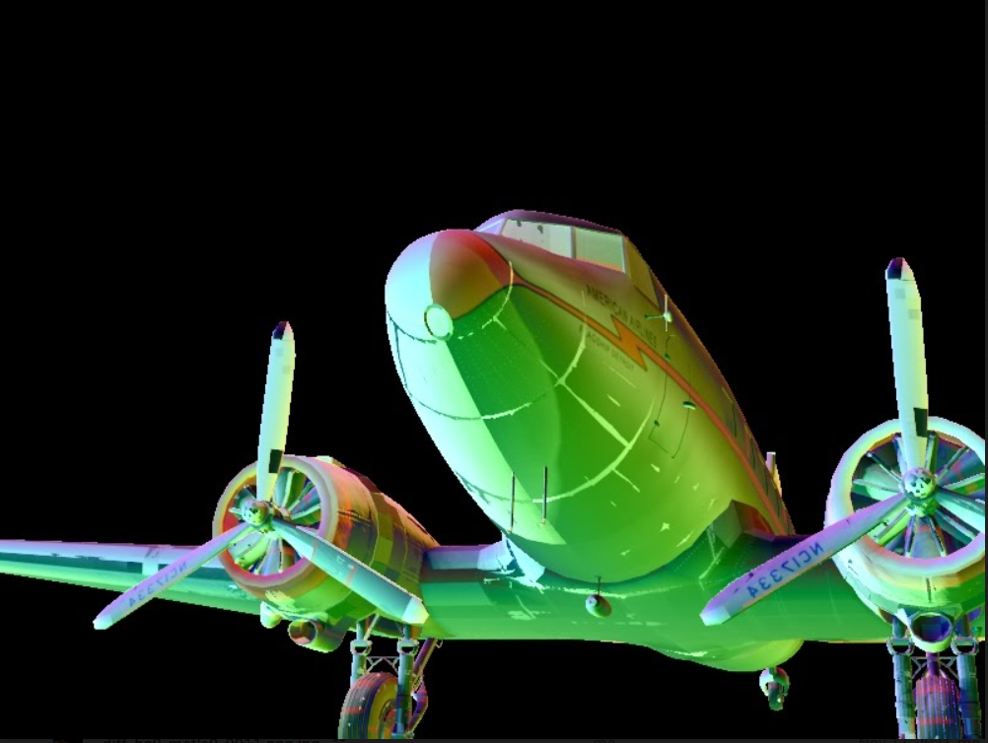

## 5. differentiable rendering approach

#### 5.1 feasibility of this approach

**Experiment**s:

Intensive experiments were implemented to explore the potential of differentiable rendering model.

Firstly, we experimented on targe images ang source images that are same type.

* Both normal images
* Both depth images

For the case that source and target image are of the same type, the distance of two image could be simply designed as pixel wise different

Here is an example showing that optimization process with target image and source image are both normal image.

Target normal image initial normal image difference image

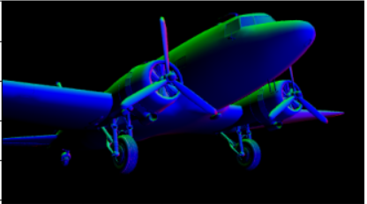 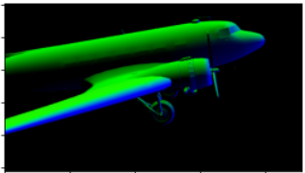 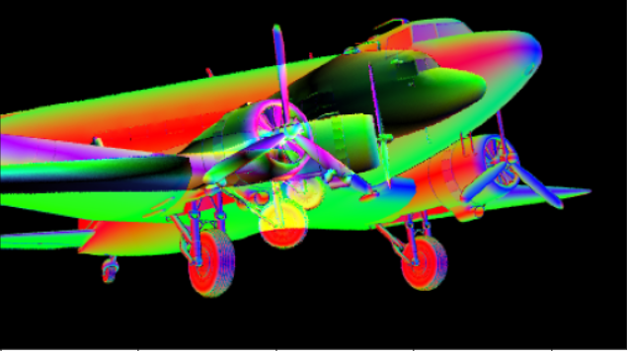

The graphs below demonstrate the optimization process whith Iteration number of 300.

The chart on the left plot the loss change with respect to number of iteration.

The graph on the right shows the final difference of the two images, where they are completely overlap. The current post of source image is what we are looking for.

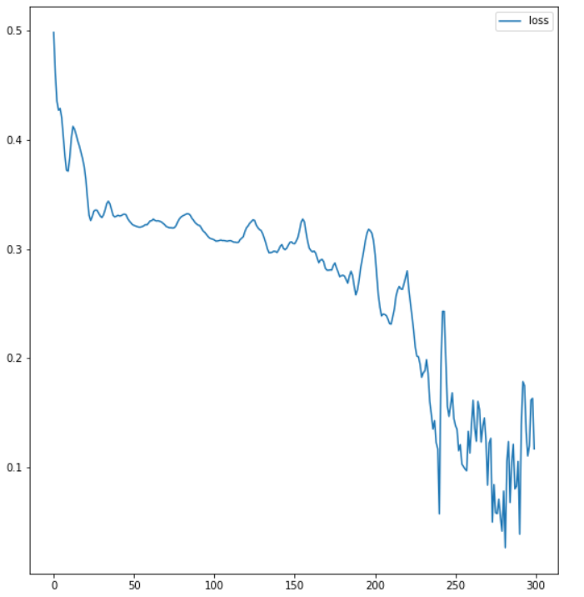 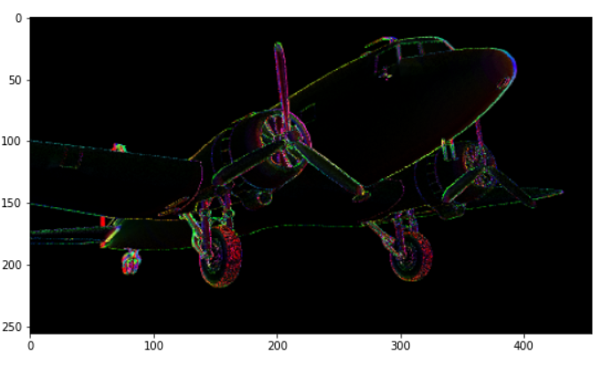

run “Cam_optim_by_renderred_target.ipynb”

See animation at “appendix/out_diff_normal_imgs.avi” to visualize the optimization process.

**Analysis and challenge:**

* For cases where both target image and source images are of sample type (e. g.). The result looks promising.
* Different type of target image and source image

Our target images are RGB image, and source images are another type of image (e.g. normal images which are generated by Redner). Measuring and minimizing the distance between two different type of image is challenging for this optimization model.

#### 5.2 Distance measurement:

* **Optional 1: Engineered feature extractor.**

The idea of this approach is capturing the edge map from both image by applying edge filters (such as Sobel, Canny…), then calculate the distance of edge maps. Target images are processed to remove the backgrounds.

Experiments results shows bad performance, the optimized pose is hard to converge to target pose.

An example shows below:

Edge of target image Edge of surce image Difference of edges

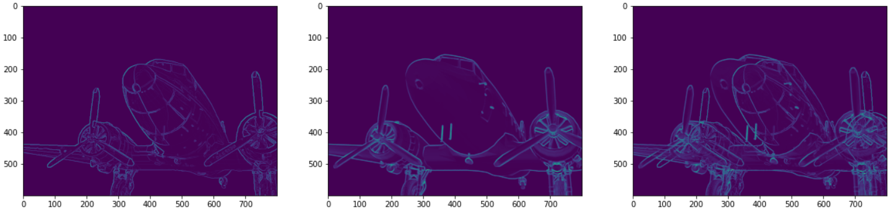

Training optimization process ends up pushing the source edge image further and further away

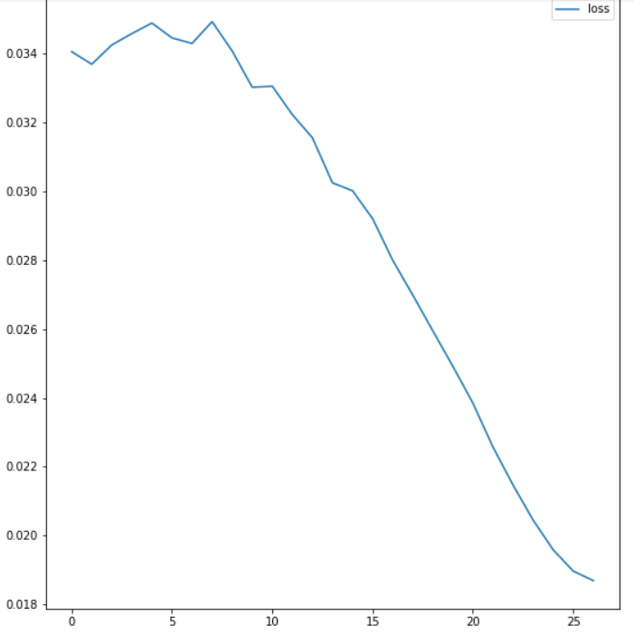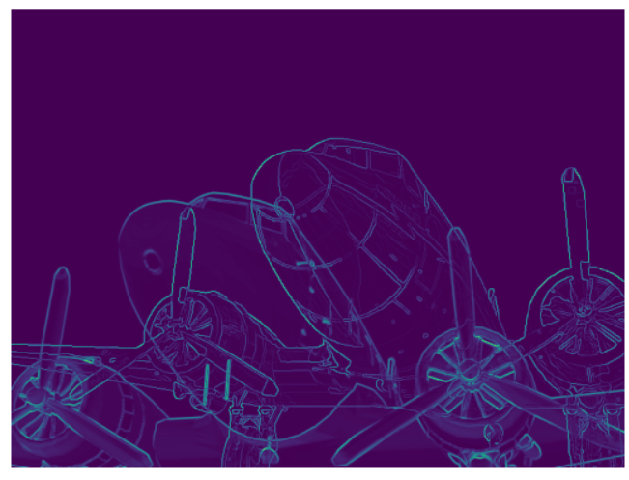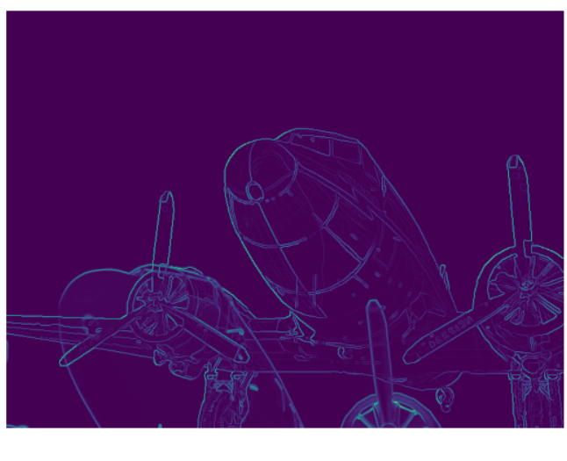

**Result and analysis:**

* Some factors contribute to bad convergence: noise on the edge due to different textures and appearance. The information on the edge feature images is not sufficient enough for optimization model.
* We also tried to smooth image (e.g. Gaussian filter) before applying edge exaction feature. It didn’t help too much.
* **Option2: machine learning feature extractor**

Idea: we expect to learn feature extractor by Deep Learning Network. We hope the network will implicitly learn the features from a pair of images of different type, and output the distance of the two images. We intend to apply certain constraint on loss function in order to make the d(T, Si) monotonically increase given a sweep of source image with increasing deviation from the perfect macheted position, where Si is source image, I = 0,1,2…n (n is number of source images in sweep)

Dataset, Architecture, and loss function

**Dataset:**

1. we generate batches of source pose sequences with increasing perturbation to target pose, toward both positive and negative direction, which are comprised of metadata file. The strategy of producing the source pose with increasing deviation is described in the notebook “Gene_training_data.ipynb”

2. render source image as normal images using Redner model.

3. size of training data: 750 sequences, 10 source image for each sequence. Validate data has 250 sequences, test has 10.

Try couples of different architecture and combination of functions.

**Architecture 1:**

**Architecture summary:**

ConvNet1 and ConvNet2 are two separate convolutional network intend to learn features from a pair of images with different types, then pass them to ConvNet3 with shared weight. The output of two branches will be flatten and output the distance D(T, S) after the computation node “Difference of 2 Vectors” where various adaptation can be applied here.

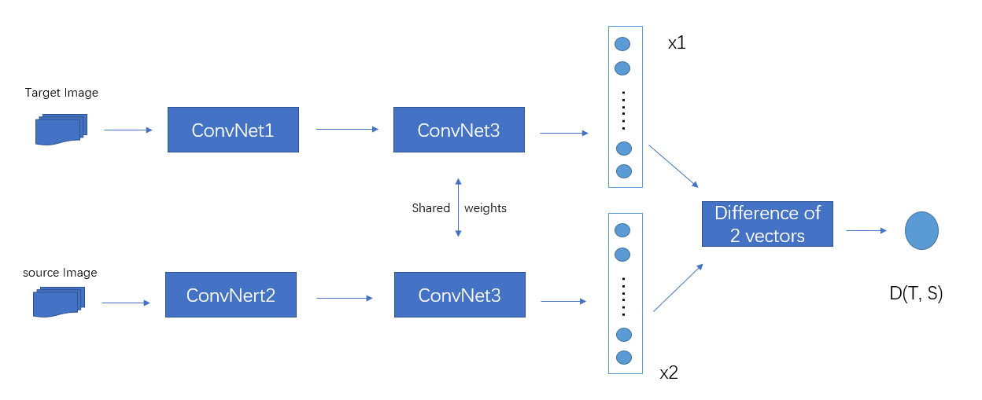

Loss function design:

Assume that we have a series of source images with increasing deviation from the pose of target image, we hope that the network output the distance d(T, Si) is increasing as well, i = 1, 2, …n (n is the number of source images in this sweep)

Loss = w1* t1 + w2*t2 + W3*t3

t1: D(T, S0) is the distance between the first source image in the sweep and target image, they keep the same pose. We hope the perfectly matched pose produce the minimal distance.

T2: ReLU(-dd) where dd is difference of adjacent distance, dd = [ D(S, S1)- D(S, S0), D(T, S1)- D(T, S0), ….. D(T, Sn)- D(T, Sn-1) ]. We hope this term push dd to non negative

T3: sum(alpha* sigmoid(dd)) where alpha is weight vector. We hope this term push dd >0 during training.

**Experiments on machine learning model:**

Intensive experiments are conducted by various combination of

* loss function and adaptation
* ML architecture

to explore potential configuration.

**Architecture1: Customed Neural Network**

Last Layer Mode:

1 – L2 abs(x1-x2).

2- L2 norm(x1-x2)

3 – (x1-x2) followed by fully connected layer

4 – square(x1-x2) followed by fully connected layer

Loss: consist of three terms T1, T2, T3, we tried to explore how they effect the learning result.

Performance range (0 -5): 0 not good at all, 5 great

|  |  |  |  |  |  |  |  |
| --- | --- | --- | --- | --- | --- | --- | --- |
| Train type | Dropout layers | Last Layer Mode | Loss = T1 + T2 + T3 | | | Performance  Range 0 - 5 | Detail |
| T1 | T2 | T3 |
| Training 1 | no | 1 | yes | no | Yes (without sigmoid) | 0 | See here |
| Training 2 | no | 1 | yes | no | Yes (with sigmoid) | 0 | See here |
| Training 3 | no | 1 | yes | yes | Yes (with sigmoid) | 0 | see here |
| Training 4 | no | 1 | yes | yes | Yes (with sigmoid) | 0 | See here |
| Training 5 | No | 3 | yes | yes | Yes (with sigmoid) | 0 | See here |
| Training 6 | No | 3 | No | Yes | yes | 0 | See here |
| Training 7 | no | 3 | No | No | Yes (with 1 -sigmoid ) | 1 | See here |
| Training 8 | no | 3 | Yes (abs(t1)) | No | Yes (with 1 -sigmoid ) | 0 | See here |
| Training 9 | No | 2 | Yes (abs(t1)) | no | Yes (with 1 -sigmoid ) | 0 | See here |
| Wight : 1  Weight: 0.1 | Weight: 1  Weight: 0.9 | 3 |
| Training 10 | No | 2 | no | no | Yes (with 1 -sigmoid ) | 2 | See here |
|  |  |  |  |  |  |  |  |
| Training 11 | No | 4 | Yes(Weight: 0.1) | no | Yes(Weight: 0.9) | 2 | See here |
| Training 12.1 | yes | 4 | Yes(Weight: 0.1) | no | Yes(Weight: 0.9 ) | 2 | See here |
| Training 12.2 | yes | 4 | Yes(Weight: 0.1) | no | Yes(weight: 1) | 0 | See here |
| Training 13 | Yes | 2 | no | no | Yes (with 1 -sigmoid ) | 0 | See here |
| Training 14 | no | 2 | Yes(Weight: 0.1) | no | Yes(Weight: 0.9) | 3 | See here |
| No | 2 | Yes (weight 0.1) | No | Yes (weight 1) | 3 |

Detail results see the Apendix “Learning network result analysis”

More epochs on charts : e.g. 200

Results from above experiments shows some potentials, but we also notice it’s a little bit far from ideal effect, and the limited ability of generalizing to validate data.

**Architecture 2: (leverage existing CNN )**

Replace the ConvNet1, ConvNet2 with two separate Restnet18 as CNN feature extractor, and drop the shared ConvNet3

Result: Predicted distance from network for source images in sweep:

|  |  |  |  |  |  |  |  |
| --- | --- | --- | --- | --- | --- | --- | --- |
| Training type | CNN model | Shared conv part | T1 | T2 | T3 | performance | detail |
| Exp2_1 | Resnet18 | No | Yes (0.1) | no | Yes (0.9) | 0 | See here |
| Exp2_2 | Resnet18 | no | No | yes | yes | 2 | See here |

Overall, results from some models shows some promising potential in this direction although it is still not closed to the satisfied result. Both architecture and loss function should be revisited and improved.

**Network performance detail analysis:**

We develop script to analysis the learning performance (see “comparator_training_analysis.ipynb”)

It helps us to closely observe those sweeps with best and worst convergence performance during the training process

in training and validate data.

* How to run “comparator_training_analysis.ipynb”:

set configuration files under “analysis” section in “training_config.ymal

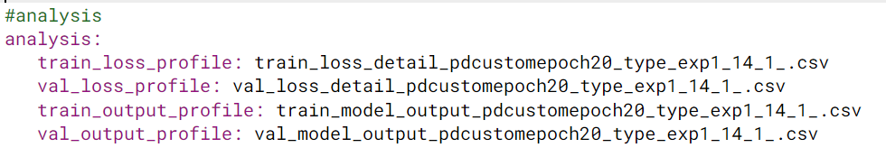

**Example: ( A complete case analysis see “ comparator_training_analysis.pdf ”)**

* Train and validation loss

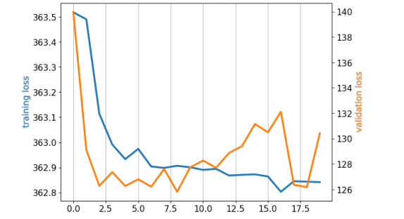

* Distribution of loss term slope across training and validation examples

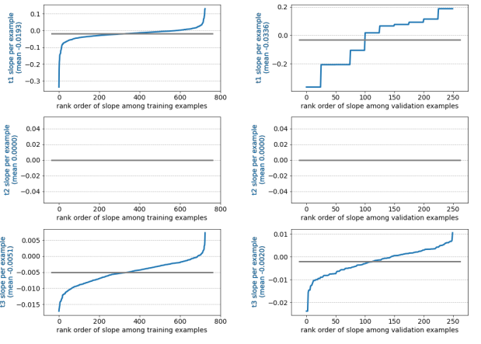

* Show top and bottom performance from validation data

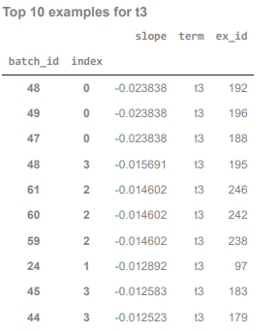 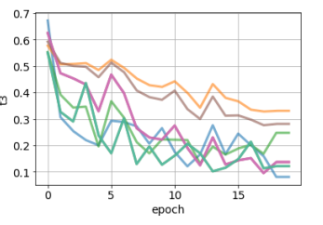

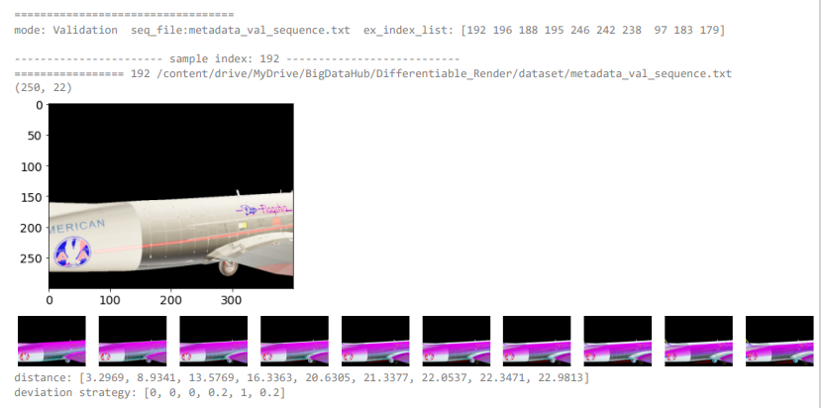

#### 5.3 Plug network into pose optimization model:

**Comparison of engineered feature extractor and machine learned extractor**

Run “Cam_opt_by_ml_and_filters.ipynb” notebook to compare the two approachs.

Compared to engineered edge extractor( e.g. sobel, Canny), machine learning feature extractor looks more promising. Take a look at an example below:

5.3.1 using machine learning network

**Example:**

Original source image difference

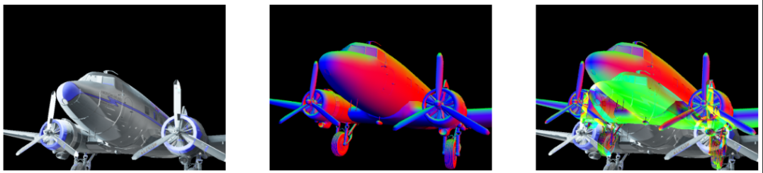

After around 90 epochs, we got a decent convergence of source and target image. Check the complete optimization process video “opt_process/network_opt_65_21.avi” (the 65th record in metadata_val_sequence.txt, source image index 21)

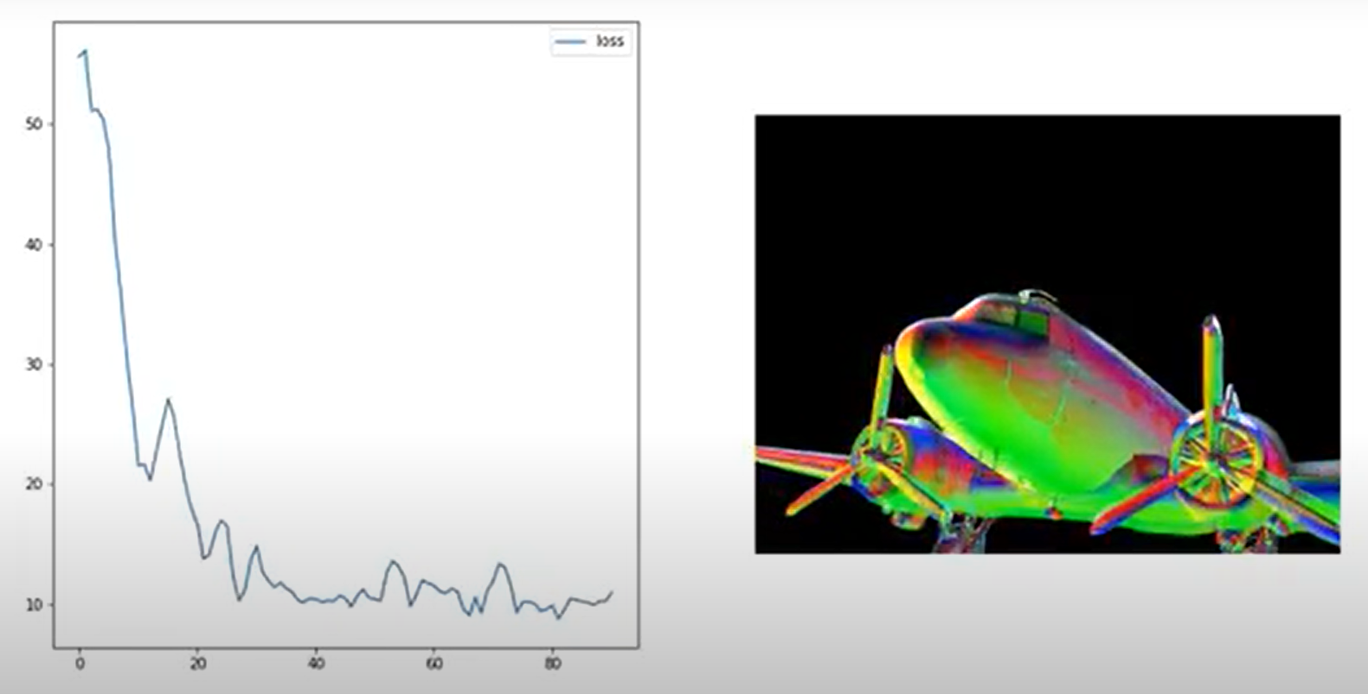

**Plot the top performance with smallest loss**:

We plot the difference image with 3 lowest loss in ascending order.

The optimization converge looks promising for this initial pose.

From difference images, we notice that the pose at the lowest loss is not the best match. Actually pose at the third lowest loss looks much better, which indicates there still some work to improve the machine learning model.

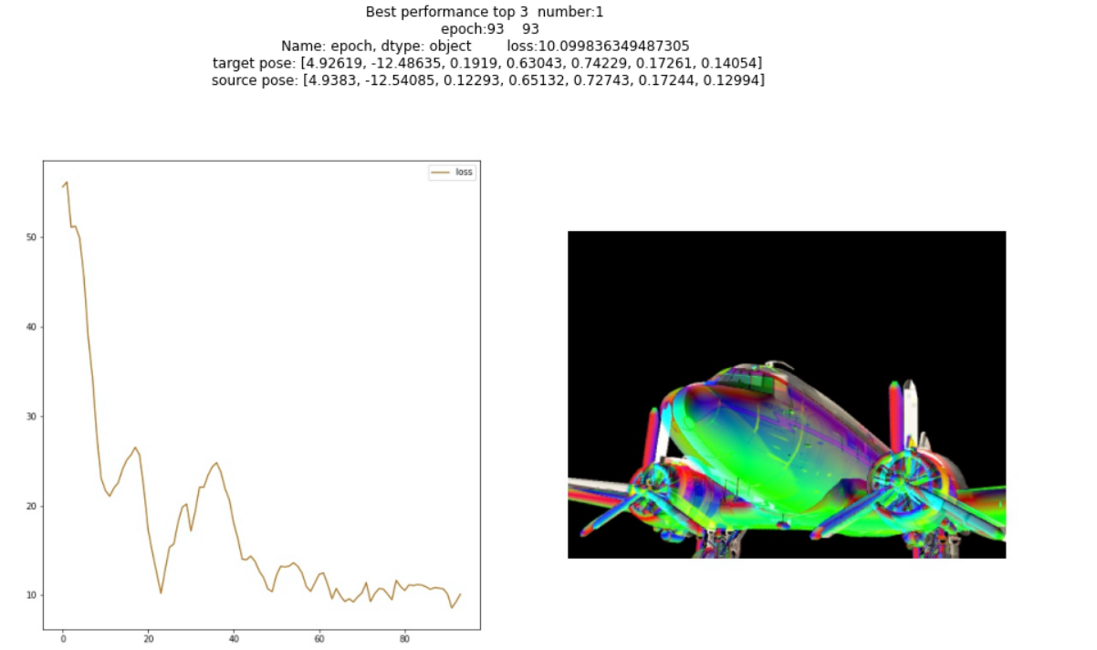

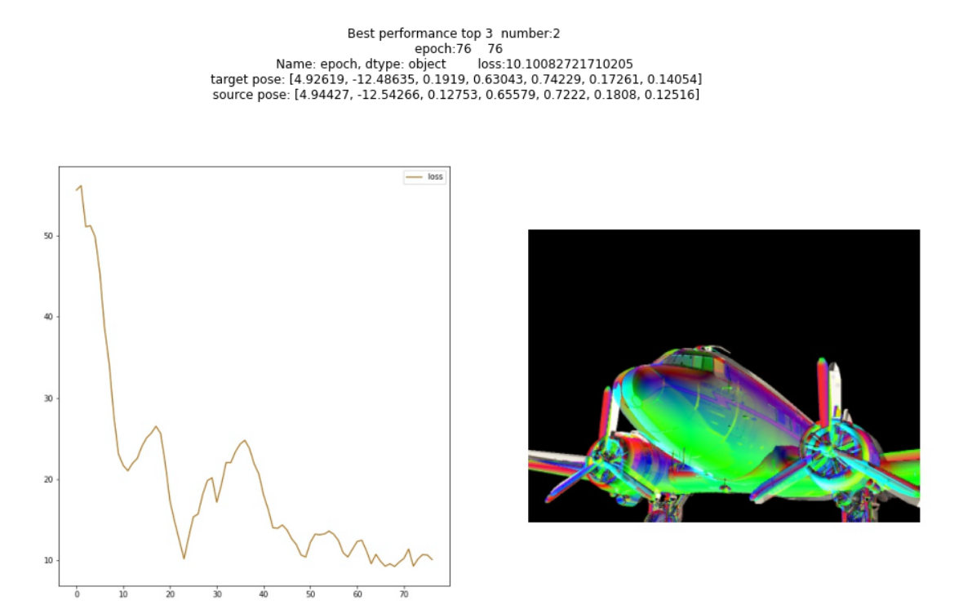

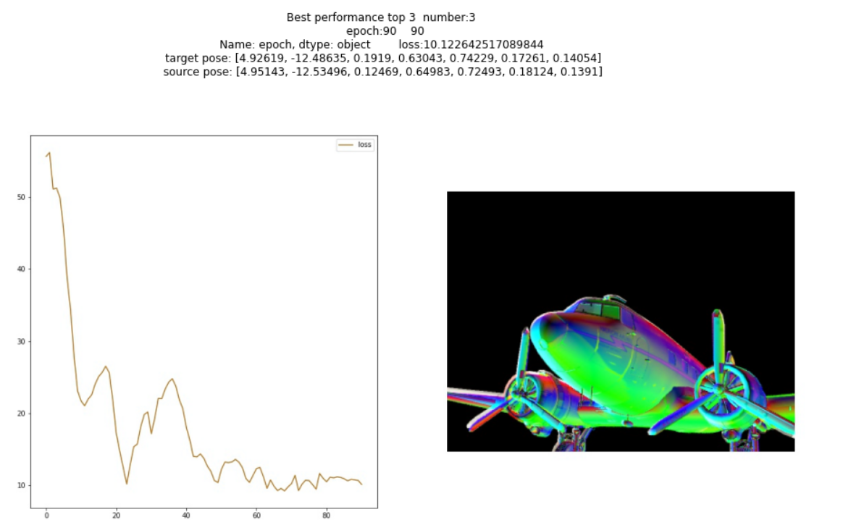

Plot the Pose distance between source image and target image

We also plot the change of distance between source image pose and target image pose.

A pose is represented by position x, y, z and rotation quaternion, w, x, y, z

We calculate the position distance and rotation distance separately, as “dir_t” and “dir_r” respectively in the chart below.

The green line “dis_com” is combine the two distance with weights: dis_com = 0.7*dir_r + 0.3*dir_t. rotation distance gets more weight we notice that the change of camera rotation cause greater movement of airplane on the image.

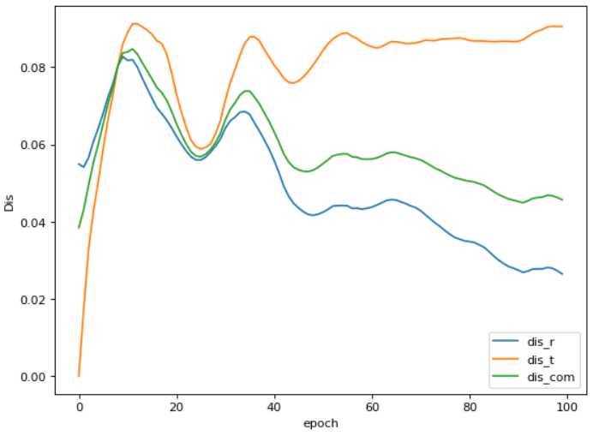

5.3.2 using Edge filter:

We try various edge detection filter (e.g. Sobel, Canny, Gaussian+ Sobel, Gaussian + Canny). However, by using edge filter to extract feature for optimization performed badly, seen the source image keep moving further off the right position, although the loss decreased. Finally the source image completely move out of the view.

Check the optimization process video “opt_process/edge_opt_65_21.avi”

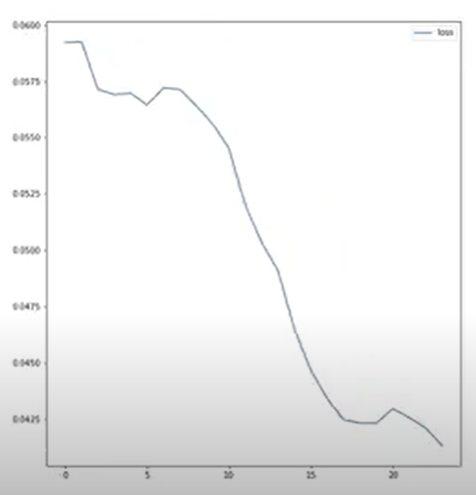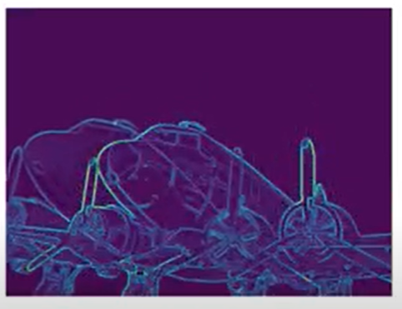 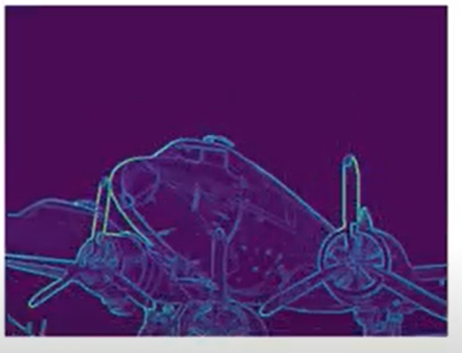 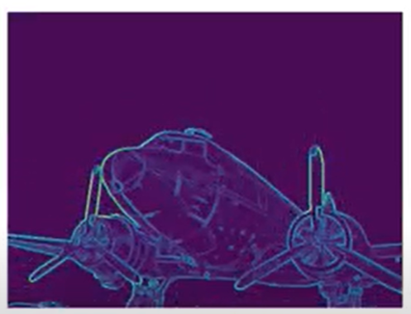

The graph below shows that the change of distance between source edge images and target edge image keeps growing and finally end up with the result where source image moved out of image.

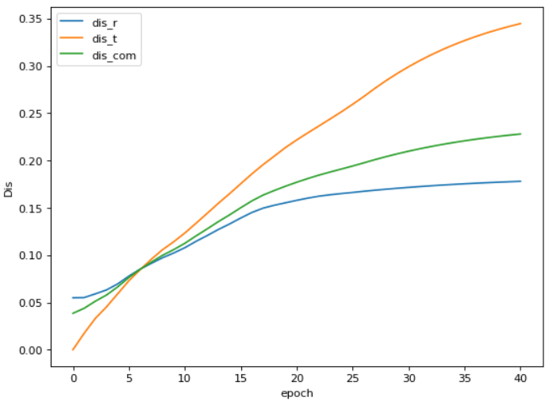

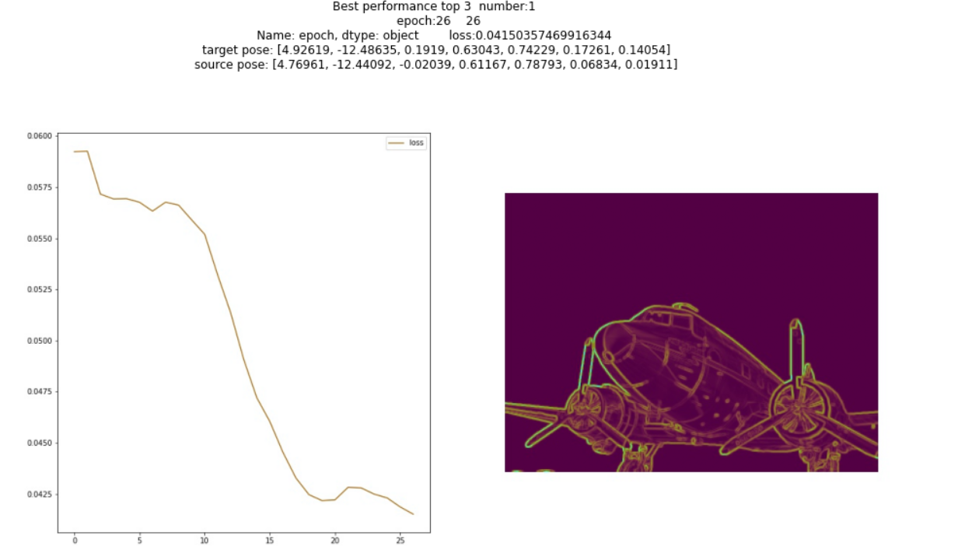

You can run “**Cam_opt_by_ml_and_filters.ipynb**” to compare more case between engineered and machine learning feature extractor.

## 6. Conclusion:

Base on the previous research, recent work focus on solving the pose optimization problem using differentiable rendering model, with facilitate of deep learning methods.

* Intensive experiments were conducted to explore differentiable rendering methods.
* Compared to engineered edge extractor, machined learning feature extractor did dramatically improve the performance of calculating the distance between two images with different types, which provides a much better convergence when it is plugged into pose optimization model.
* The performance is still not stable and the optimized pose is not precise enough to meet the high accuracy requirement of this project
* The limitation of this approach also subjective to the dataset used to training the machine learning model.
* This approach has its potential to solve this 2D 3D anchoring problem. However, many work are worth to try in order to find the best machine learning architecture and loss function.

## 7. Reflection and future work:

Improving current method:

* Dataset:

The dataset currently used for training seems not sufficient to be generalized. We suggests generate around 5 times more sequences(750*5= 2750) to training. This could be helpful for the overfitting problem during training.

* Architecture:

1. Existing CNN (eg, ResNet, VGG) are courage to be used as feature extractor in first part of network

2. Retrieve the high level and low level feature representation from Existing CNN models (eg. ResNet, VGG). Those layers could be further learned to benefit our distance calculation between two different type of image.

- Loss function

How to devise a better loss function which can push the distance of adjacent source image be in the positive manner for each sequence. Current constraint is not strong enough to make majority to training data to reach that level.

Other potential approach

* Vidloc + LSTM

Vidloc : A Deep Spatio-Temporal Model for 6-DoF Video-Clip Relocalization

<https://arxiv.org/abs/1702.06521>

* Machine learning method to learn normal image from target RGB image. Because our experiments proof that the Redner pose optimization model work well on two normal images.

Marr Revisited: 2D-3D Alignment via Surface Normal Prediction  
<https://arxiv.org/pdf/1604.01347.pdf>

Appendix:

Experiment Comparison Tables:

#### Experiment table 1:

|  |  |  |  |  |  |  |  |
| --- | --- | --- | --- | --- | --- | --- | --- |
| Train type | Dropout layers | Last Layer Mode | Loss = T1 + T2 + T3 | | | Performance  Range 0 - 5 | Detail |
| T1 | T2 | T3 |
| Training 1 | no | 1 | yes | no | Yes (without sigmoid) | 0 | See here |
| Training 2 | no | 1 | yes | no | Yes (with sigmoid) | 0 | See here |
| Training 3 | no | 1 | yes | yes | Yes (with sigmoid) | 0 | see here |
| Training 4 | no | 1 | yes | yes | Yes (with sigmoid) | 0 | See here |
| Training 5 | No | 3 | yes | yes | Yes (with sigmoid) | 0 | See here |
| Training 6 | No | 3 | No | Yes | yes | 0 | See here |
| Training 7 | no | 3 | No | No | Yes (with 1 -sigmoid ) | 1 | See here |
| Training 8 | no | 3 | Yes (abs(t1)) | No | Yes (with 1 -sigmoid ) | 0 | See here |
| Training 9 | No | 2 | Yes (abs(t1)) | no | Yes (with 1 -sigmoid ) | 0 | See here |
| Wight : 1  Weight: 0.1 | Weight: 1  Weight: 0.9 | 3 |
| Training 10 | No | 2 | no | no | Yes (with 1 -sigmoid ) | 2 | See here |
| Training 11 | No | 4 | Yes(Weight: 0.1) | no | Yes(Weight: 0.9) | 2 | See here |
| Training 12.1 | yes | 4 | Yes(Weight: 0.1) | no | Yes(Weight: 0.9 ) | 2 | See here |
| Training 12.2 | yes | 4 | Yes(Weight: 0.1) | no | Yes(weight: 1) | 0 | See here |
| Training 13 | Yes | 2 | no | no | Yes (with 1 -sigmoid ) | 0 | See here |
| Training 14 | no | 2 | Yes(Weight: 0.1) | no | Yes(Weight: 0.9) | 3 | See here |
|  | No | 2 | Yes (weight 0.1) | No | Yes (weight 1) | 3 |
|  |  |  |  |  |  |  |  |

#### Training 1:

Loss keeps drop to big negative number, which is not what we want

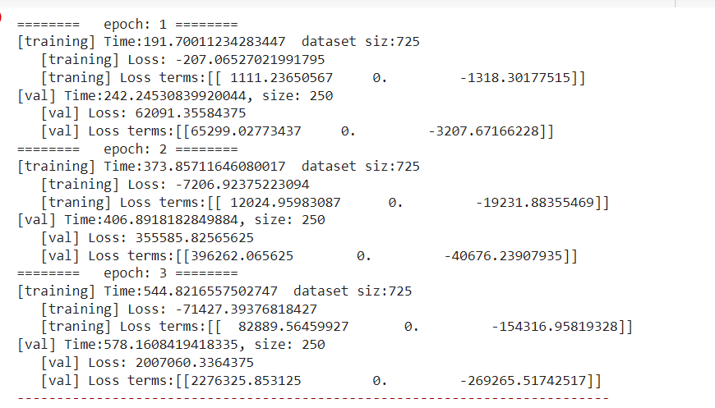

#### Training 2:

Model push output to zero at some point, which result in

dd =0, t1-> 0 , t3 -> 0.5

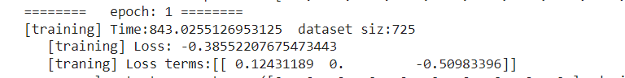

output of 10 source images (the distances),

some satisfy increasing pattern

some hard to meet the requirement.

The model push all the distance to zero to meet the constraints of loss function

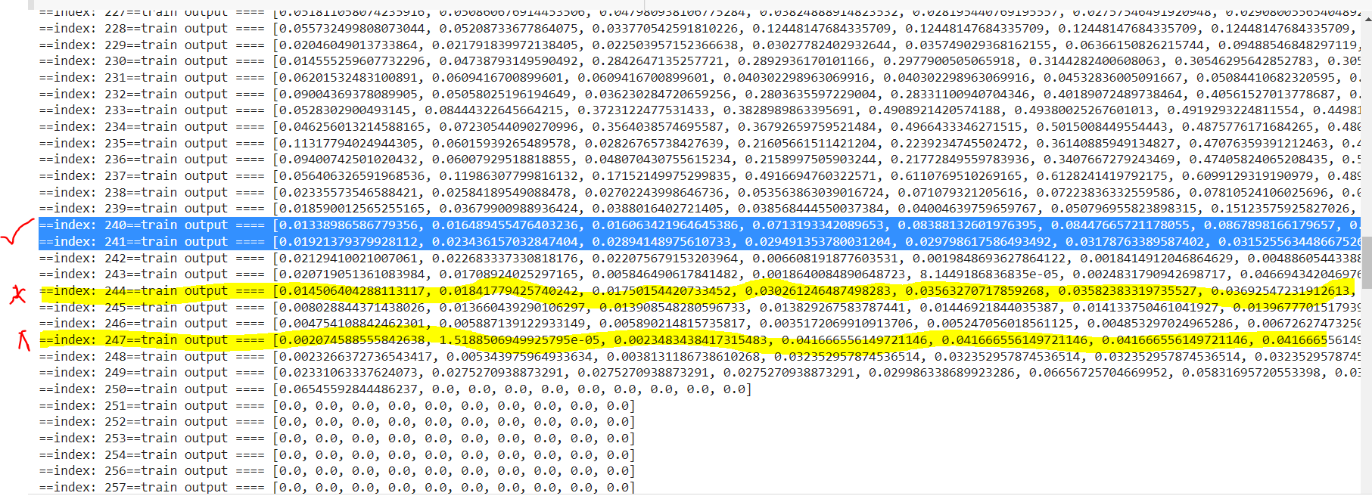

Issue: After around 250 training samples, almost all the output are trained to zero.

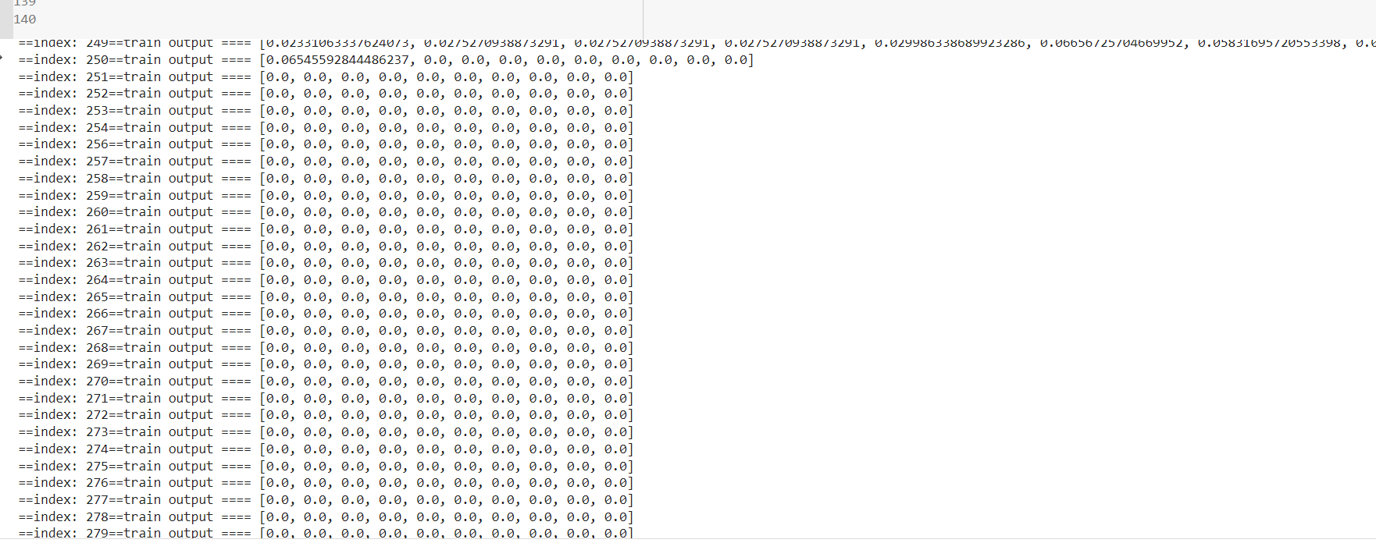

#### Training 3:

Similar with the result above, with the training ongoing, distance of source images are push to zero.

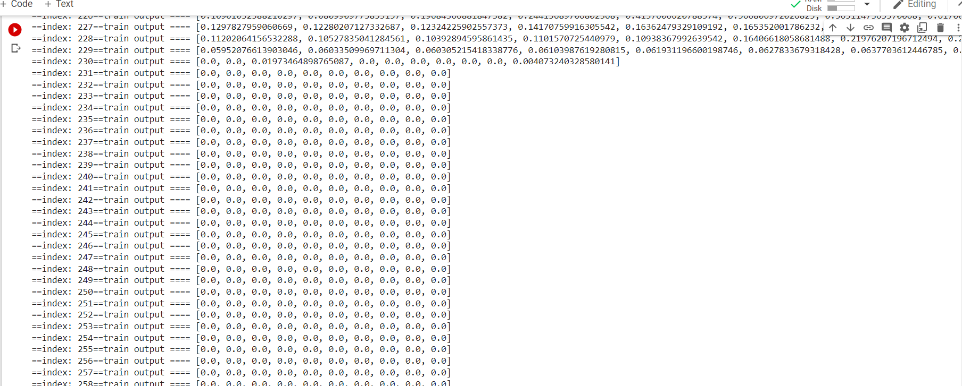

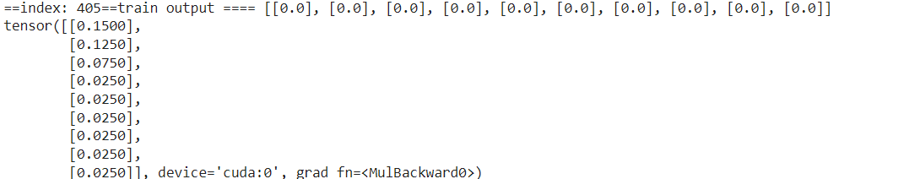

Model push output -> [0,0,0,0,0,0,0,0,0,0] so dd -> [0,0,0,0,0,0,0,0,0], then t3 -> -0.5

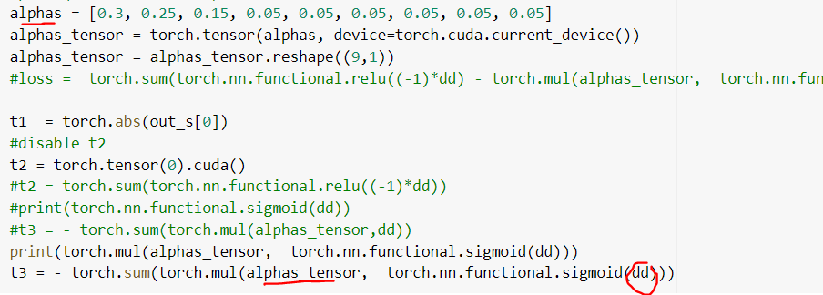

#### Training 4:

Result similar to above

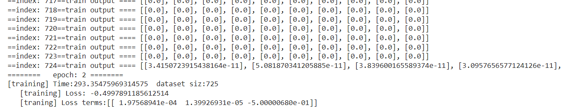

#### Training 5

Result is similar to above

Outputs -> 0s, so that the t1 ->0 t2 -> 0 t3->-0.5, then loss -> -0.5

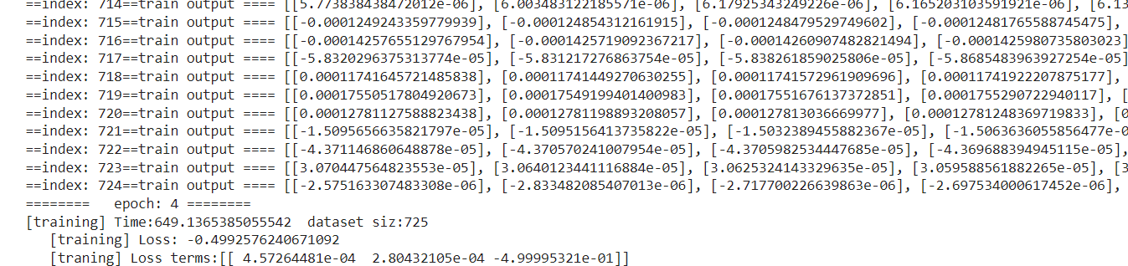

#### Training 6:

Without t1, 20 epochs:

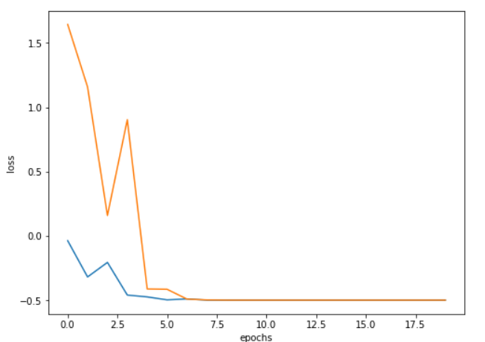

Decreasing Speed of T3 become slower with more epochs, then T2 push dd -> 0 to make loss be minimum

The loss function should be revised.

#### Training 7

Loss function without t1 and t2, keep t3 as 1-sigmoid:

Without the constraint of t1, some changed emerge, they not 0s anymore, although d0 tends to be erratic

Distances are mostly **negative**, although some dd (difference between distances) sweep keep increasing, which is not that ideal

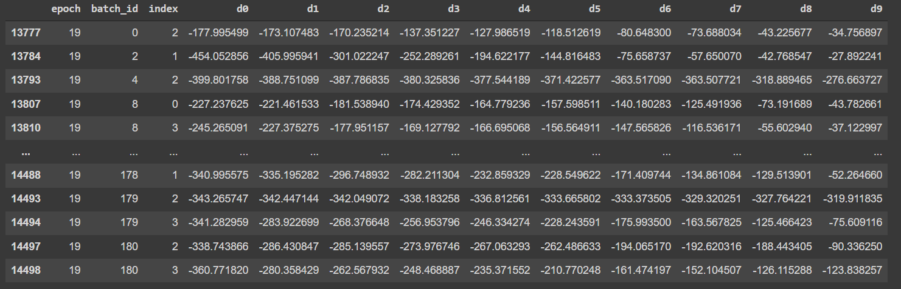

From plot of loss during training, we notice the validation data didn’t converge well

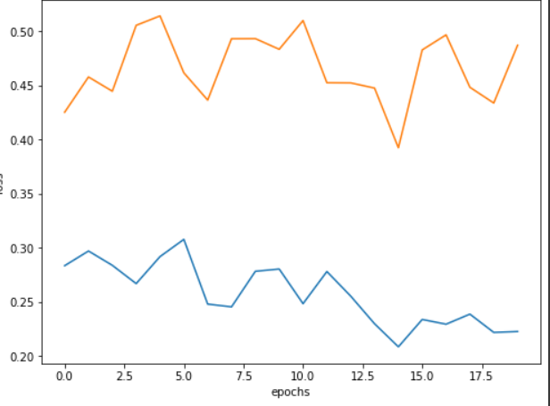 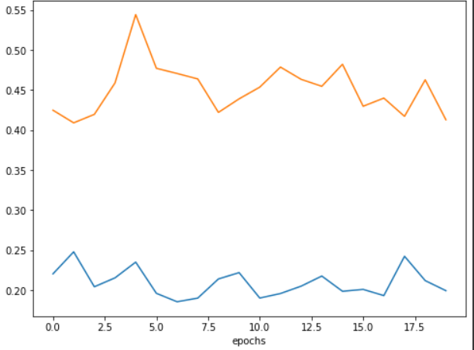

We hope to introduce some constraint in loss to ideally push output should be positive, since outputs are supposed to present the distance between two image:

**Alternatives:**

* **Replace the linear layer to normal of two embedding vector? (training 9)**
* **Keep the last linear layer and add t1(ads(d0)) in loss to push d0 close to 0 (training 8)**

#### Training 8:

Distance between source images become almost the same.

Which lead loss to 0.5, similar to previous experiment

Output snippet:

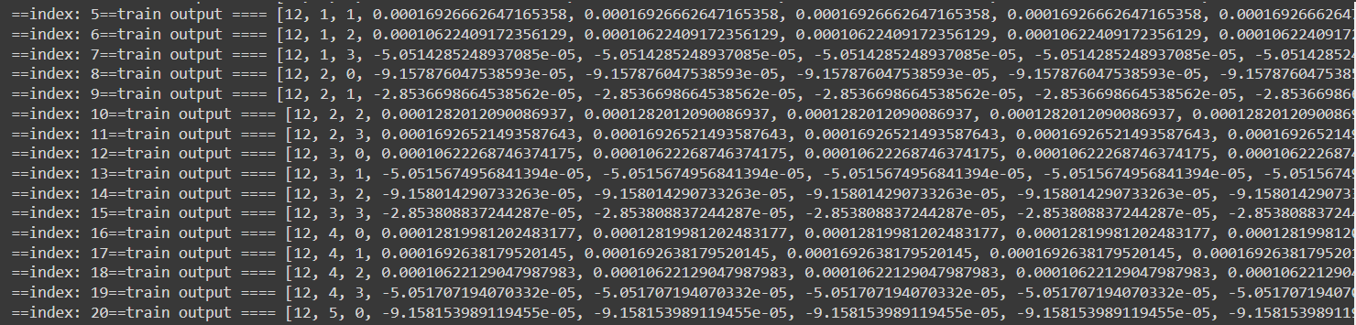

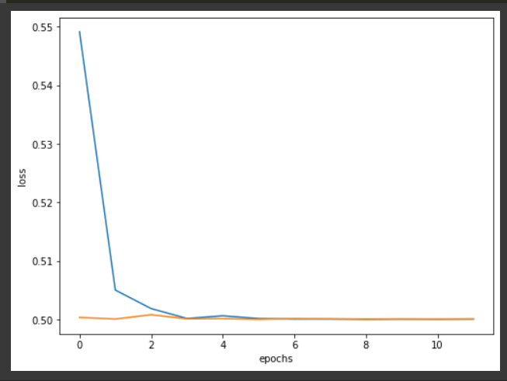

#### Training 9:

**Similar with above**

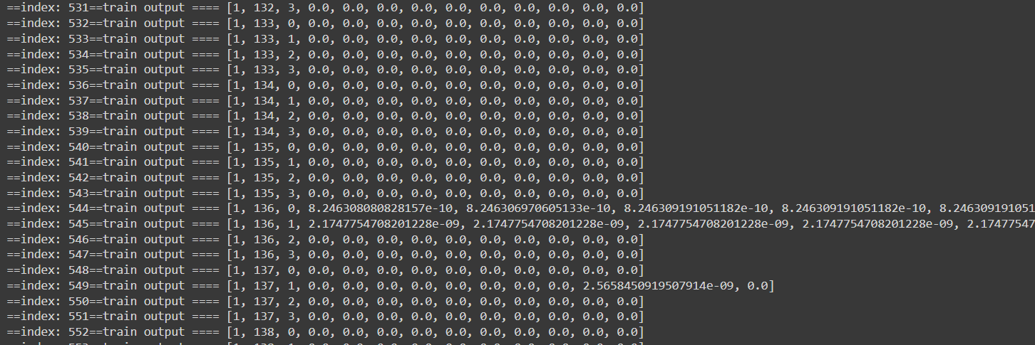

**If we apply weight on t1: Loss = 0.1 * t1 + 0.9* t3.**

**It improve a lot**

**20 epoch + 20 epoch+ 20 epoch：(training continuously)**

Training 227/725 288/725 293/725

Validate: 75/250 60/250 55/250

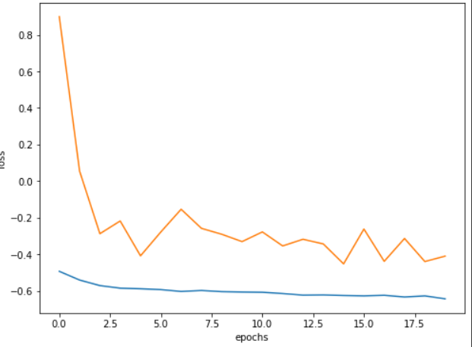 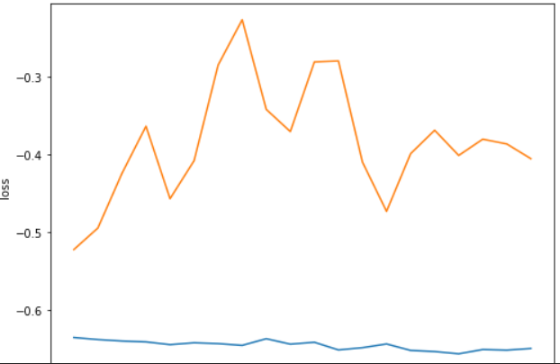 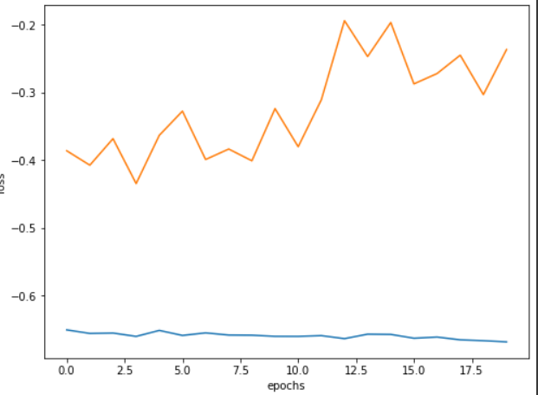

[**pros**] training loss keeps drooping to around 0.8

[**overfitting**] : With increasing epochs, we notice the deteriorating performance on validation data

#### Training 10：

**Use Only t3**

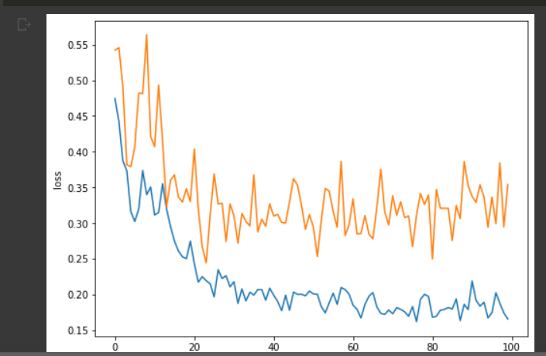

After 100 epoch, 230/725 samples in training data meet the requirement: increasing distance in source images. But various d0 value are overserved:

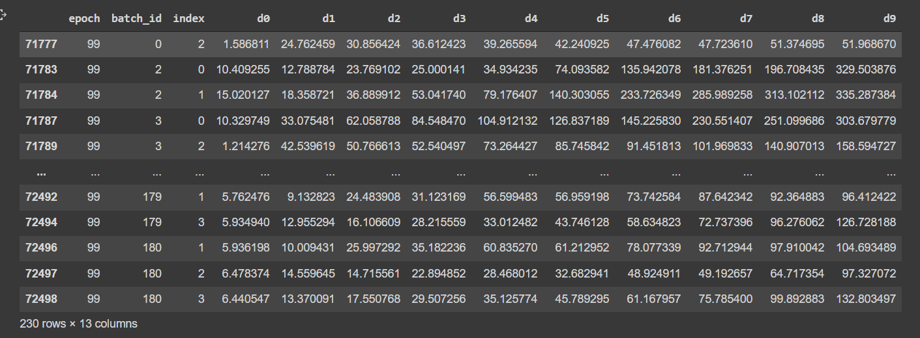

52/250 samples in validate data process the sweep as increasing distances

#### Training 11:

Training loss training data: 283/725 qualified

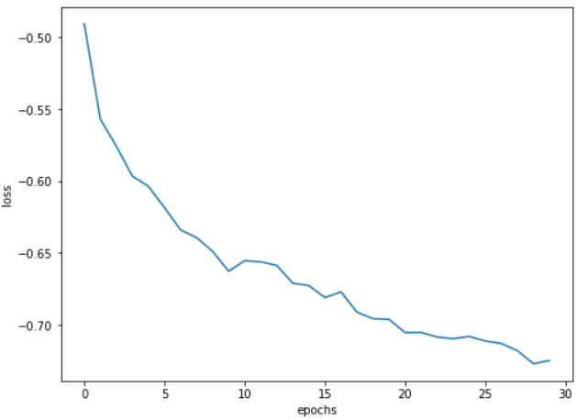 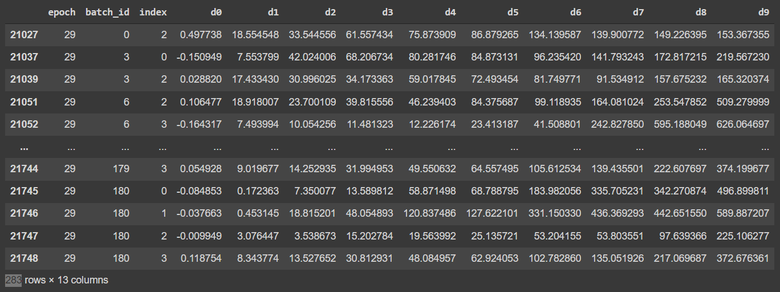

Validation data: 74/725 qualified

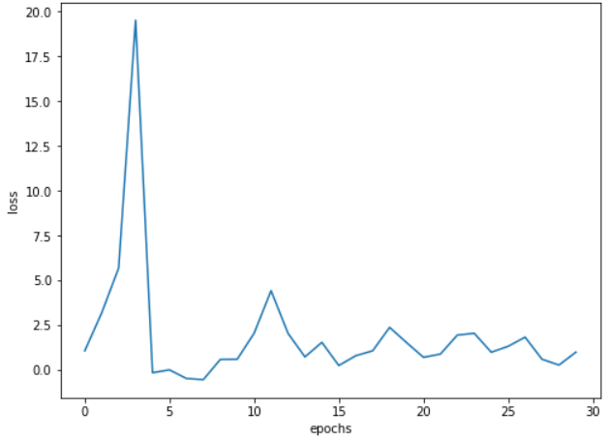 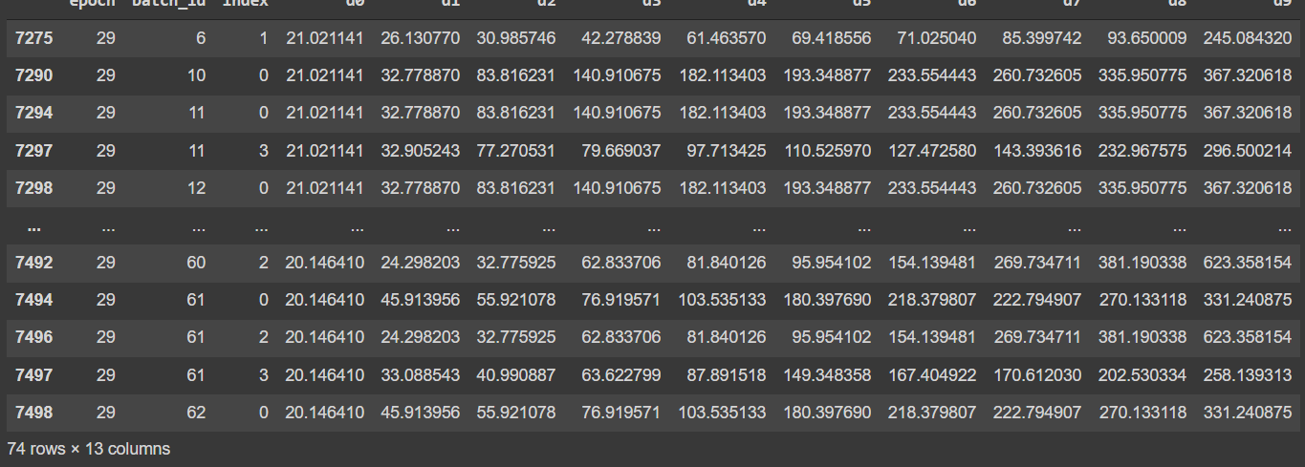

Train and validate loss: overfitting problem still exists

First 20 epochs Next 20 epochs

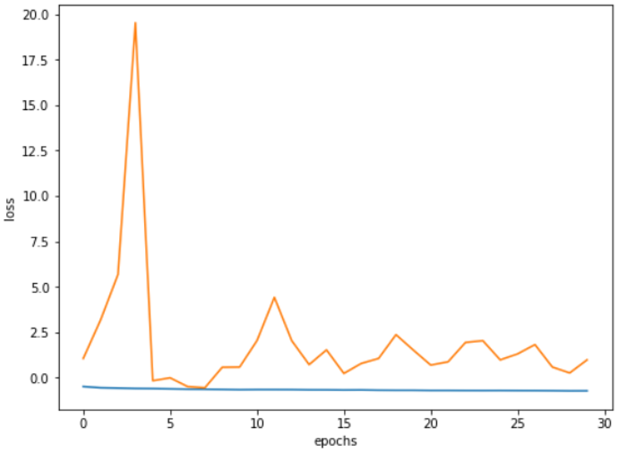 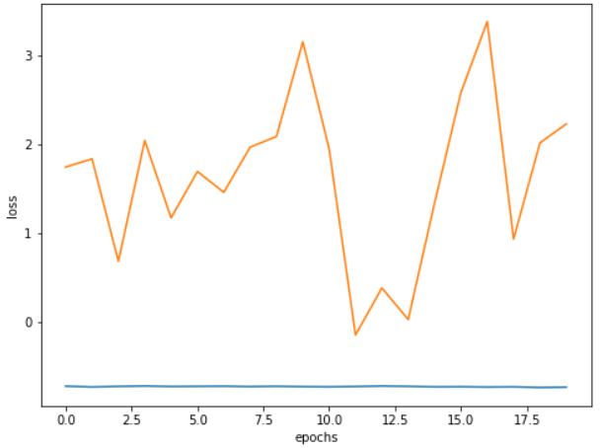

#### Training 12.1:

* Training 20 epochs:

Train loss: Train data: 49/725 qualified

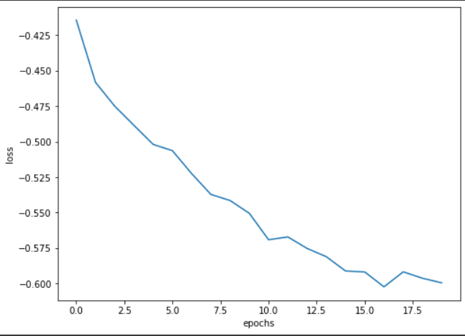 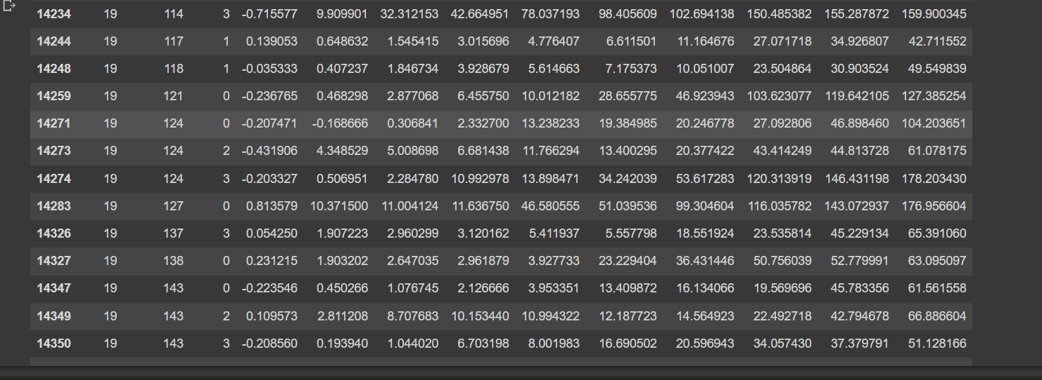

Val loss qulified Val data 51/250

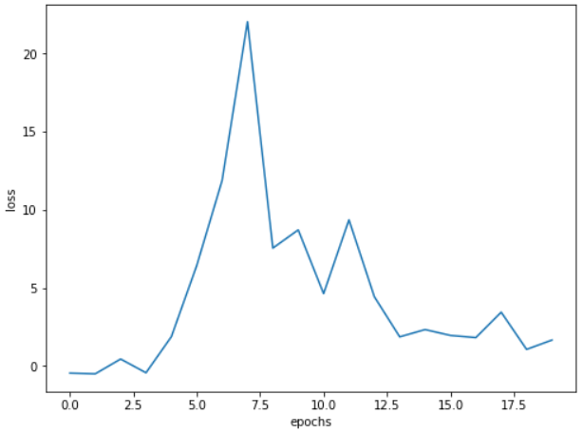 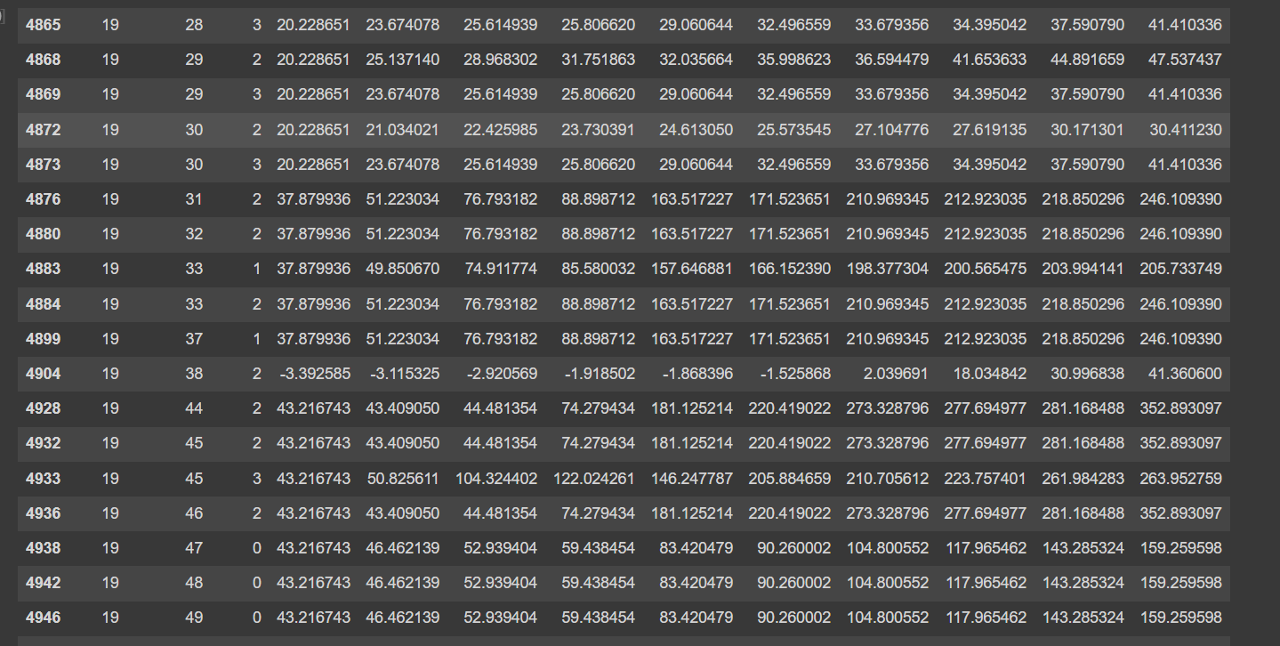

**-**train 40 epochs. Train data 70/725

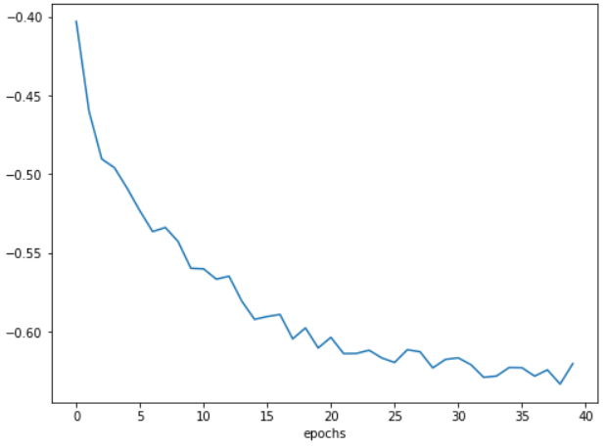 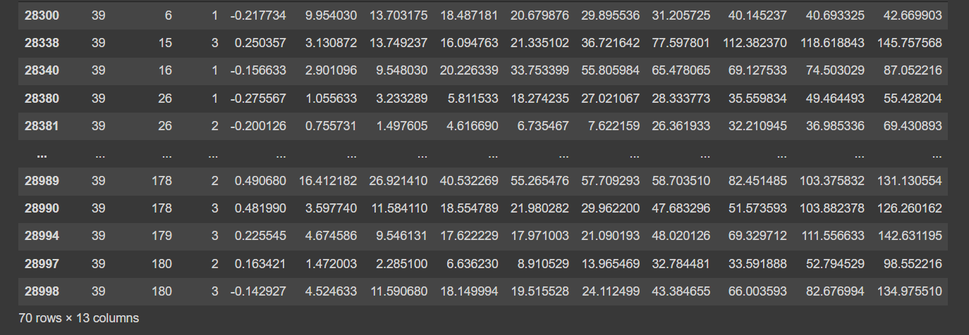

Val data 16/250

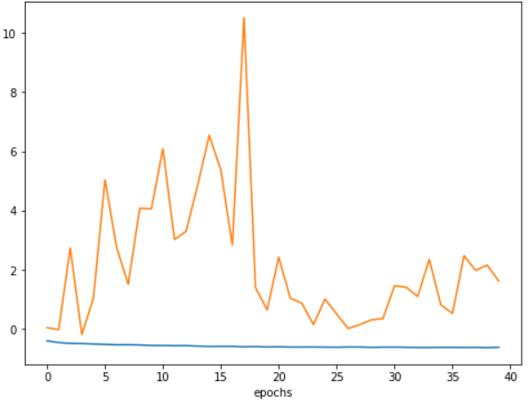 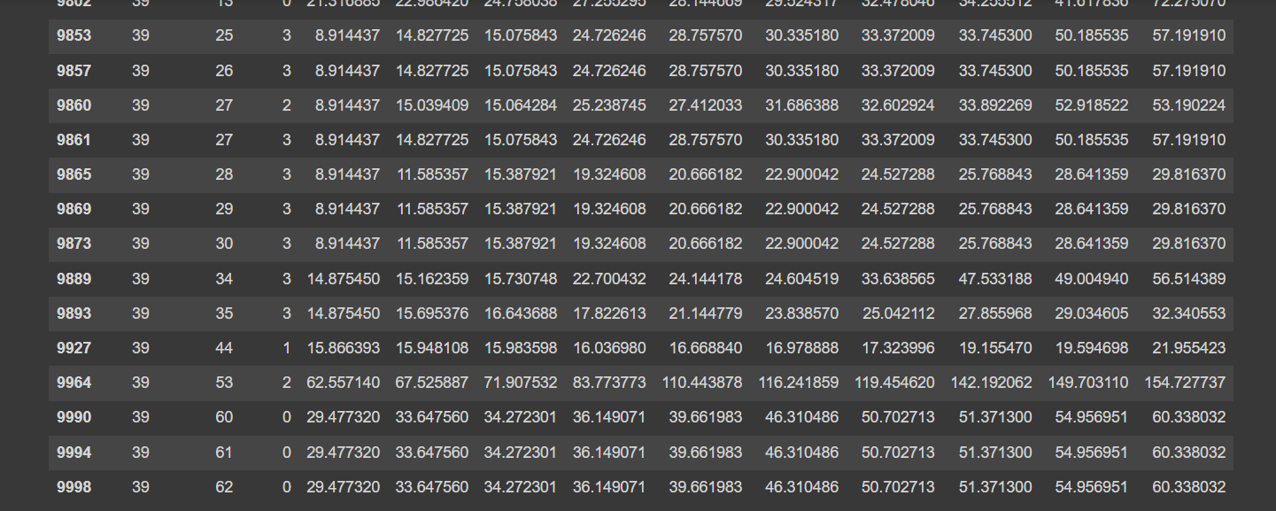

#### Train 12.2

T1 weight 0.1, t2 weight 1:

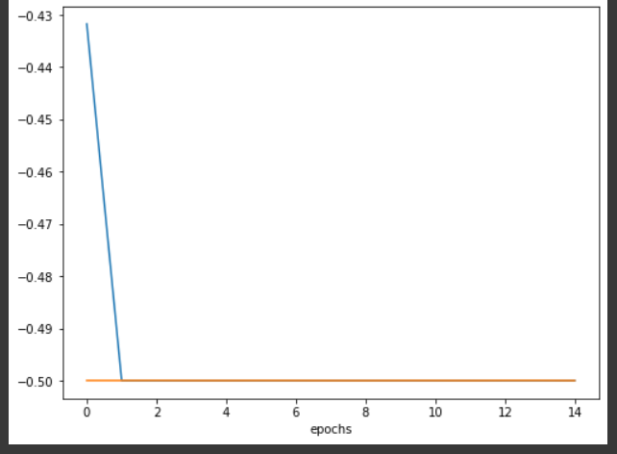

#### Training 13:

Push t1 -> 0 and t5 -> -0.5 , dd -> 0

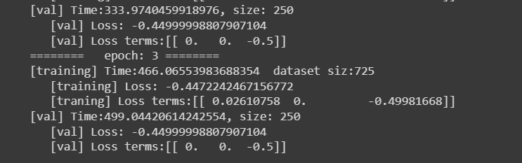

#### Training 14.1

Training and validation loss:

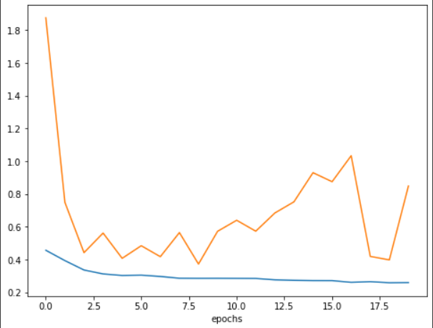

Training 274/725

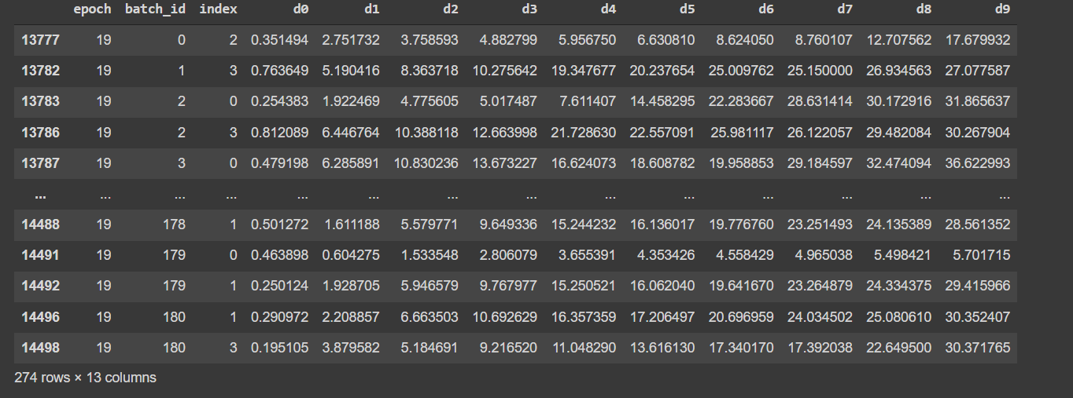

Validate data 76/250

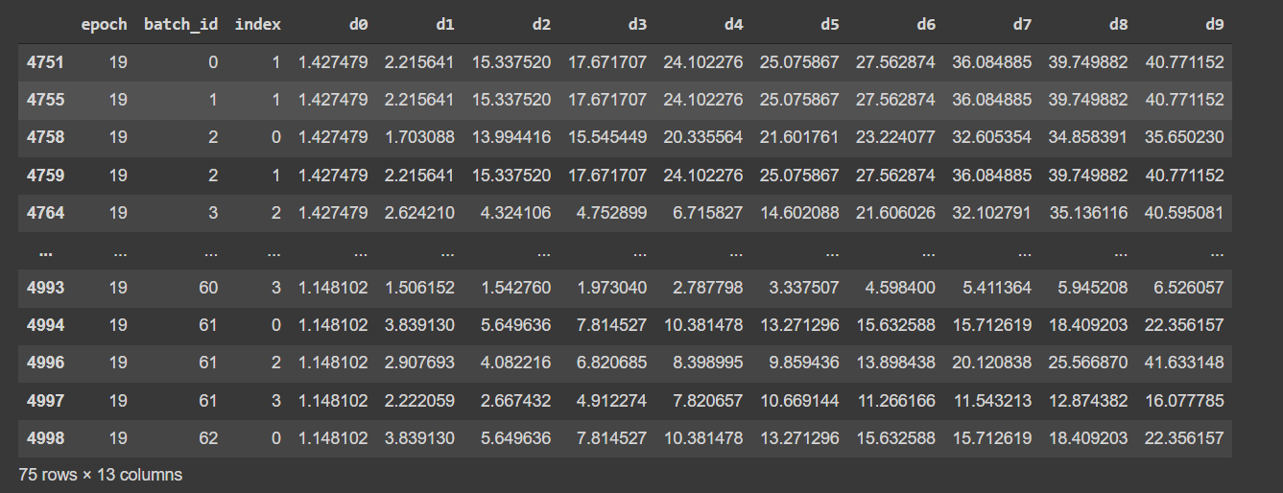

#### Training 14.2:

Train and validate loss:

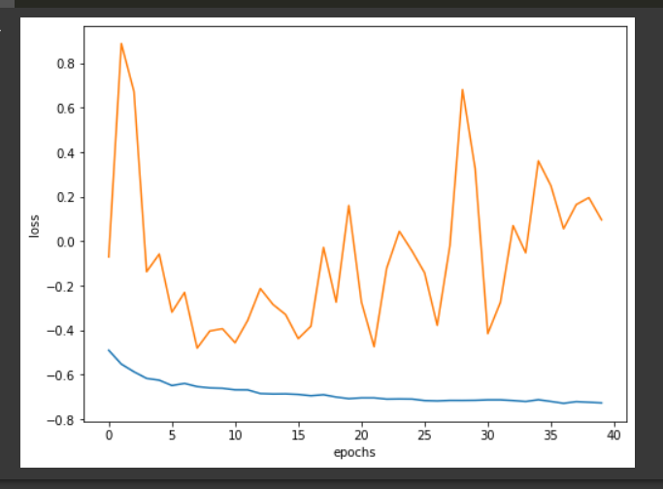

Train data, qualified 306/725

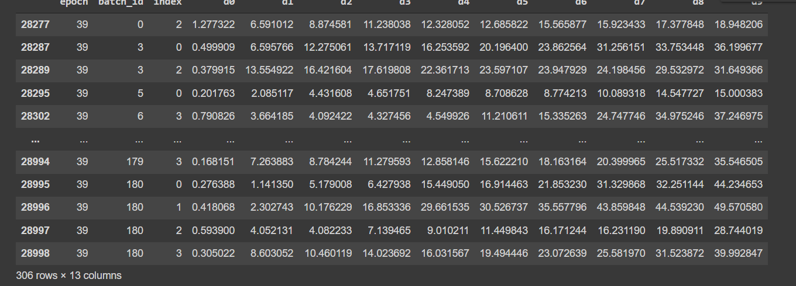

Val data: qualified 69/250

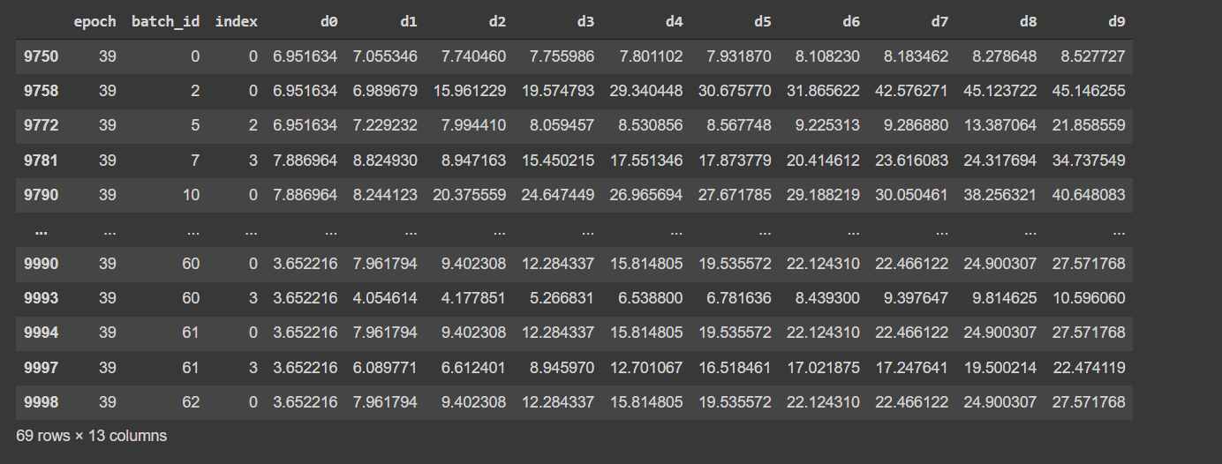

### Experiment Table2:

|  |  |  |  |  |  |  |  |
| --- | --- | --- | --- | --- | --- | --- | --- |
| Training type | CNN model | Shared conv part | T1 | T2 | T3 | performance | detail |
| Exp2_1 | Resnet18 | No | Yes (0.1) | no | Yes (0.9) | 0 | See here |
| Exp2_2 | Resnet18 | no | No | yes | yes | 2 | See here |

#### Experiment 2.1

Failed, dd converge to 0s

#### Experient 2.2:

Training and validate loss in 20 epochs

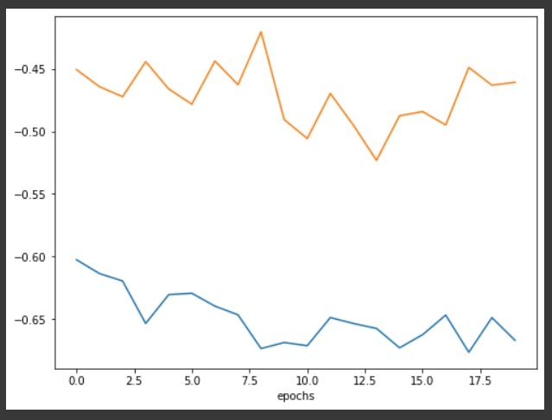

Training data: 60/725 meets requirement of increasing distances in sweep

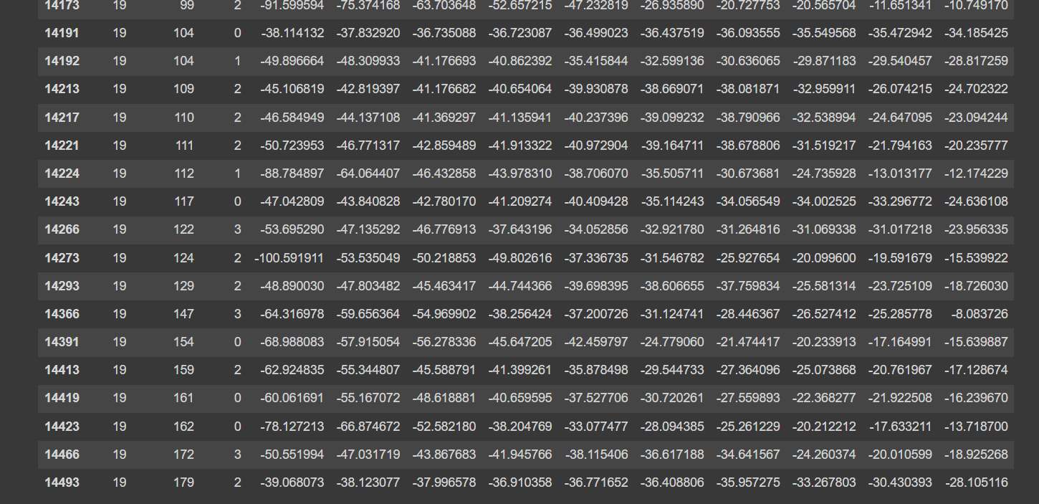

Validate data 4/250

